Emergency dissemination in Vehicular Ad Hoc Networks: Design and Evaluation of a Bounded Gossip-Based Protocol

by
Boris Gor
Supervisor:
Professor Adnan Al-Anbuky

A Research Project Report submitted to Auckland University of Technology in partial fulfilment of the requirements for the degree of Master of Engineering

Faculty of Design and Creative Technologies School of Engineering, Computer and Mathematical Sciences

2026

Abstract 3
1. Introduction 4
2. Literature Review 7
3. System Model and Design 11
4. Implementation 15
5. Experiments and Results 26
6. Discussion 34
7. Conclusion and Future Work 38
References 40
Appendix A. Mobility Trace Preparation from OpenStreetMap and SUMO 41
Appendix B. Cooja Scenario Preparation and Headless Execution 42
Appendix C. Log Processing and Graph Generation 43
Appendix D. Simulation Configuration Summary 44

Abstract
Vehicular Ad Hoc Networks (VANETs) enable direct communication between vehicles to support safety-critical applications such as emergency warnings and cooperative traffic management. However, their highly dynamic topology and frequent network fragmentation make reliable message dissemination difficult to achieve. Conventional routing-based and infrastructure-dependent approaches often degrade under such conditions or rely on assumptions that do not hold in sparse or intermittently connected environments.
This work investigates emergency message dissemination under prolonged fragmentation using an adaptive gossip-based dissemination protocol, referred to as the Bounded Gossip-based Kernel Protocol (BGKP). The protocol combines bounded retransmission, adaptive peer selection, and store-carry-forward buffering in order to study whether state-based emergency dissemination can be supported on constrained embedded platforms while retaining predictable and resource-bounded operation.
The study includes the implementation of three dissemination protocols in Contiki-NG, the development of urban and highway mobility scenarios, and the creation of a simulation and post-processing pipeline for extracting performance metrics.
The system is implemented in Contiki-NG and evaluated in the Cooja simulation environment using both trace-driven urban mobility derived from OpenStreetMap and SUMO and controlled highway mobility generated within Cooja. Comparative experiments are conducted against two baseline approaches: a flooding-based broadcast protocol and a minimal dissemination baseline, across multiple node densities and connectivity regimes.
The results show a mixed outcome rather than a uniform advantage for BGKP. In the urban scenario, BGKP consistently achieves the highest packet delivery ratio across the evaluated densities, with values remaining near 0.43-0.66, but this is obtained at the cost of substantially higher average latency and higher absolute transmission overhead than either baseline. In the highway scenario, BGKP achieves the highest delivery ratio only at the lowest densities, after which the DUMB baseline performs better in RSU-delivered data ratio. For emergency dissemination, BGKP does not demonstrate systematic superiority in convergence time: the flooding baseline generally achieves faster emergency t50, t90, and t99 values, especially as density increases.
These results indicate that BGKP is best understood as a trade-off design rather than a dominant dissemination solution. Its main benefit in the present evaluation is improved RSU-delivered data retention in the urban fragmented setting, while its costs are substantially higher latency and transmission overhead, and its emergency convergence performance does not consistently exceed that of simpler baseline approaches.

Introduction
Vehicular Ad Hoc Networks (VANETs) enable direct wireless communication between vehicles and surrounding infrastructure to support safety-critical and traffic efficiency applications such as emergency notifications, collision avoidance, and cooperative traffic management. Unlike conventional wireless networks, VANETs are characterised by high node mobility, rapidly changing network topology, variable node density, and frequent network fragmentation. These properties significantly complicate reliable message dissemination, particularly in sparse or intermittently connected environments.
Much existing VANET research prioritises delivery-centric performance metrics, often under assumptions of sufficient connectivity or infrastructure support. However, in many realistic vehicular scenarios—such as highways, rural areas, and regions with limited Roadside Unit (RSU) coverage—persistent end-to-end connectivity cannot be assumed. Vehicles may experience extended periods of isolation, during which no forwarding opportunities are available. In such conditions, dissemination mechanisms that rely on stable routes or continuous connectivity often exhibit unpredictable behaviour, excessive control overhead, or inefficient resource usage.
The purpose of this study is to investigate whether a lightweight, adaptive dissemination protocol can support emergency notification under prolonged fragmentation without relying on infrastructure.
In this work, communication stability is understood as the ability of a dissemination mechanism to operate in a predictable and resource-bounded manner under highly dynamic conditions, including intermittent connectivity, sustained network fragmentation, and the absence of end-to-end communication paths. Temporary non-delivery is not treated as a failure; instead, stable operation is characterised by bounded communication overhead, controlled use of local storage, and gradual, non-oscillatory degradation of behaviour as network conditions worsen.
A key distinction addressed in this project is the difference between transient disconnections and prolonged fragmentation. While brief connectivity interruptions are commonly considered in existing dissemination designs, prolonged fragmentation introduces qualitatively different challenges. When the duration of isolation exceeds the inter-arrival time of generated messages, dissemination behaviour becomes dominated by storage pressure and buffer management rather than forwarding efficiency. Protocols that implicitly assume eventual contact or effectively unbounded storage may therefore exhibit uncontrolled resource consumption or silent information loss under such conditions.
Decentralised gossip-based (epidemic) dissemination mechanisms provide an alternative to route-dependent communication by exploiting opportunistic forwarding and controlled redundancy. By relying on local interactions and probabilistic forwarding, such approaches can tolerate frequent topology changes and uncertain connectivity. However, epidemic dissemination is sensitive to network density, forwarding parameters, and buffer availability, making static configurations unsuitable across the diverse operating conditions encountered in realistic vehicular networks. This motivates the use of adaptive mechanisms combined with explicit resource bounding.
Accordingly, this study does not assume that adaptive gossip will dominate simpler baseline mechanisms under all conditions. Instead, it examines how such an approach behaves across different connectivity regimes and what trade-offs arise in delivery, latency, communication cost, and emergency convergence when dissemination is implemented on constrained embedded platforms.
Despite the extensive work on routing, flooding, and gossip-based dissemination in VANETs, existing approaches primarily optimise delivery performance under assumed connectivity conditions. Less attention has been given to the behaviour of such mechanisms under prolonged fragmentation, where end-to-end communication cannot be assumed and resource constraints become dominant.
In particular, it remains unclear how emergency dissemination mechanisms behave when implemented with bounded buffers, limited retransmission, and no reliance on infrastructure support. This gap motivates the investigation carried out in this study.
The objective of this research project is to investigate whether an adaptive gossip-based (epidemic) dissemination protocol can support state-based emergency message dissemination in vehicular ad hoc networks under prolonged fragmentation, while maintaining stable and resource-bounded operation on constrained embedded platforms. The focus is not on demonstrating universal superiority in delivery or convergence performance, but on characterising dissemination behaviour and the associated trade-offs when connectivity is intermittent and resources are finite.
The central research question addressed in this work is: can an adaptive gossip-based dissemination protocol support emergency message dissemination under prolonged fragmentation in vehicular ad hoc networks, while maintaining predictable, resource-bounded operation, and what trade-offs arise relative to simpler baseline approaches?
To address this objective, the proposed approach is implemented using the Contiki-NG operating system and evaluated through simulation-based experiments conducted in the Cooja environment, with mobility inputs derived from both scenario-controlled models and externally generated SUMO traffic traces. This allows experimentation across a range of mobility, density, and fragmentation conditions while preserving realistic spatial dynamics.
Performance analysis considers packet delivery, latency, communication overhead, bounded buffer behaviour, and emergency convergence in order to identify the strengths and limitations of the approach rather than assuming consistent advantage across all scenarios.

Contributions
The main contributions of this research project are as follows:
- Design and implementation of the BGKP protocol for emergency dissemination under prolonged fragmentation.
- Experimental evaluation of dissemination behaviour across urban and highway scenarios, including comparison with two baseline protocols.
- Analysis of trade-offs between delivery, latency, communication cost, and bounded resource operation.
The remainder of this report is organised as follows. Chapter 2 reviews related work on VANET dissemination, fragmentation tolerance, gossip-based approaches, and resource constraints. Chapter 3 describes the system model and design assumptions underlying the proposed protocol. Chapter 4 outlines the implementation details, followed by experimental evaluation in Chapter 5. Chapter 6 discusses observed behaviour, limitations, and trade-offs, and Chapter 7 concludes the report and outlines directions for future work.

Literature Review
This chapter reviews existing approaches to message dissemination in VANETs, focusing on their assumptions regarding connectivity, infrastructure, and resource availability. The aim is to identify limitations of current methods under prolonged fragmentation and to motivate the design choices of the proposed protocol.

Communication Challenges in Vehicular Ad Hoc Networks
Vehicular Ad Hoc Networks (VANETs) operate under conditions fundamentally different from those assumed in conventional wireless networks. High vehicle mobility, rapidly changing topology, variable node density, and frequent network fragmentation significantly affect communication reliability and make persistent end-to-end connectivity difficult to achieve [1]. In contrast to traditional networks, link availability in VANETs is highly transient and strongly dependent on traffic density and mobility patterns.
Empirical studies based on real mobility traces indicate that extended periods of disconnection are a natural characteristic of mobile systems rather than an exceptional condition. Chaintreau et al. analyse multiple real-world datasets and show that inter-contact time distributions exhibit heavy-tailed behaviour, resulting in long intervals without contact opportunities between nodes [2]. These findings imply that frequent or regular encounters cannot be assumed even in environments with continued node mobility.
Analytical modelling of vehicular connectivity supports this observation. Khabazian and Ali demonstrate that vehicular networks do not maintain full communication connectivity at all times and may fragment into multiple disjoint clusters when inter-vehicle spacing exceeds transmission range [3]. Their model explicitly characterises the durations of connectivity availability and unavailability, showing that extended connectivity gaps are an expected property of sparse vehicular scenarios.
When the duration of isolation exceeds the inter-arrival time of generated messages, dissemination behaviour becomes increasingly dominated by storage pressure and buffer management rather than forwarding efficiency alone. This phenomenon is a central concern in Delay-Tolerant Networking (DTN) research, which explicitly models message retention and delivery under prolonged disconnection and limited resources [11]. These observations motivate dissemination strategies that treat prolonged fragmentation as a normal operating condition rather than a failure state.

Routing-Based and Infrastructure-Dependent Dissemination Approaches
Early VANET dissemination research largely relies on routing protocols adapted from Mobile Ad Hoc Networks (MANETs). These protocols aim to establish and maintain multi-hop paths and typically optimise delivery-centric metrics such as packet delivery ratio and end-to-end delay. Surveys of VANET routing protocols consistently show that routing performance degrades rapidly under high mobility and frequent topology changes [4].
Infrastructure-assisted dissemination approaches attempt to mitigate routing instability through the use of Roadside Units (RSUs), cellular connectivity, or central coordination mechanisms [5]. While such approaches can improve performance in dense urban deployments, they inherently assume the availability of supporting infrastructure. In highway, rural, or sparsely instrumented environments, these assumptions frequently do not hold, limiting the applicability of infrastructure-dependent solutions.
Consequently, both routing-based and infrastructure-assisted approaches often exhibit unstable behaviour or excessive overhead in scenarios characterised by sustained fragmentation and intermittent connectivity.

Broadcast and Flooding-Based Dissemination
Broadcast-based dissemination avoids explicit route establishment by allowing nodes to rebroadcast received messages. Flooding represents the simplest form of broadcast dissemination and offers high reachability under uncertain connectivity. However, uncontrolled flooding results in substantial redundancy and channel contention.
This effect, known as the broadcast storm problem, has been formally analysed by Tseng et al., who show that redundant rebroadcasts lead to severe contention, collisions, and performance degradation in mobile ad hoc networks [6]. Various suppression-based and probabilistic broadcast techniques have been proposed to mitigate this problem, but their effectiveness remains sensitive to node density and configuration parameters.
Flooding-based approaches therefore primarily serve as baseline mechanisms, illustrating the trade-off between reachability and communication overhead rather than providing a scalable solution.

Gossip- and Epidemic-Based Dissemination
Gossip-based, or epidemic, dissemination propagates information through opportunistic and probabilistic exchanges between nodes without requiring persistent routes or global coordination. The paradigm originates from epidemic algorithms developed for replicated database maintenance [7].
Epidemic dissemination has been shown to tolerate frequent topology changes and intermittent connectivity more effectively than routing-based approaches in mobile and vehicular environments [8]. However, fundamental analysis of gossip-based routing demonstrates that static forwarding probabilities perform well only within limited operating regimes. Haas, Halpern, and Li show that inappropriate parameter selection can lead either to excessive redundancy or to poor delivery performance, depending on network conditions [15].
Adaptive epidemic dissemination schemes attempt to address this sensitivity by adjusting forwarding behaviour based on observed network conditions. For example, Nizamoglu et al. propose a density-adaptive epidemic mechanism that exploits lane structure in vehicular networks to improve dissemination efficiency under varying traffic densities [9]. While such approaches improve delivery-overhead trade-offs, they primarily optimise delivery performance rather than explicitly targeting stable behaviour under prolonged fragmentation and bounded resource constraints.

Trickle-Based and Timer-Controlled Dissemination
Timer-controlled dissemination mechanisms regulate transmission frequency using adaptive suppression rules. The Trickle algorithm dynamically reduces redundant transmissions once information consistency is achieved [10].
Trickle relies on receiving transmissions from neighbouring nodes to trigger suppression. During extended isolation, these conditions are not met, causing transmission intervals to increase toward their maximum values [10]. Consequently, newly generated information may propagate slowly after connectivity is re-established, limiting responsiveness under prolonged fragmentation.
Although effective at reducing overhead under moderate connectivity, Trickle’s suppression-based behaviour is less suited to environments where sustained disconnection is common.

Store-Carry-Forward and Resource Constraints
Store-carry-forward dissemination originates from DTN architecture, which explicitly supports intermittent connectivity by allowing nodes to buffer messages and exploit mobility for delivery [11].
DTN research shows that buffer management decisions strongly influence dissemination behaviour under prolonged disconnection. Krifa et al. demonstrate that message drop policies directly affect delivery ratio, stability, and overhead in epidemic routing scenarios [12]. Surveys of DTN buffer management further highlight that many existing protocols assume large buffers or prioritise delivery probability over predictable resource usage [13].
These findings indicate that epidemic dissemination in fragmented networks requires explicit resource bounding and controlled buffer behaviour to achieve stable and predictable operation.

Evaluation Perspective and Research Positioning
Most VANET dissemination studies evaluate protocols using delivery-centric metrics such as packet delivery ratio and latency. DTN surveys argue that these metrics alone are insufficient in environments characterised by intermittent connectivity and prolonged fragmentation [14]. In such conditions, behavioural stability, resource usage, and degradation patterns become equally important evaluation dimensions, as reflected in the comparison of dissemination paradigms summarised in Table 2.1.
Accordingly, this work positions itself as an investigation into stable, predictable, and resource-bounded gossip-based dissemination, rather than optimal delivery under ideal connectivity assumptions.
Approach | Connectivity Assumption | Tolerates Prolonged Fragmentation | Overhead Bounded | Predictable Behaviour
Routing-based | Persistent paths | Low | Low | Low
Infrastructure-assisted | Dense RSU coverage | Medium | Medium | Medium
Flooding | None | High | No | Low
Gossip / Epidemic | Opportunistic contacts | High | Medium | Medium
Trickle-based | Periodic neighbour interaction | Medium | High | Medium
Targeted design properties | Intermittent and prolonged disconnection | High | Yes | High
Table 2.1: Dissemination Paradigms and Design Properties.

System Model and Design
This chapter defines the system model and design assumptions used to evaluate the proposed BGKP protocol. The primary design objective is effective state-based dissemination of emergency notifications across vehicular connectivity regimes, including cases where network topology is highly dynamic and intermittently connected. In this work, reliable emergency dissemination is treated as the central functional requirement, while communication “stability” is considered a secondary property that supports predictable operation and bounded resource use.
We consider a vehicular environment with moving vehicles and sparse roadside infrastructure points used as intermittent access points. In the model, vehicles are represented as mobile nodes and roadside points are represented as RSUs. Mobile nodes move independently and communicate opportunistically using short-range wireless broadcast. RSUs serve as intermittent access points that can receive data and assist local awareness of emergency conditions when vehicles pass within coverage. The interaction model is shown in Figure 3.1, where vehicles exchange information through local broadcast and opportunistically deliver stored data to an RSU when contact becomes available.
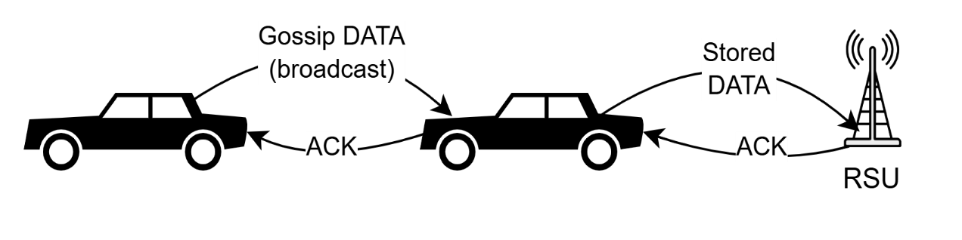
Figure 3.1: Illustration of gossip-based dissemination among vehicles and opportunistic buffer flush from a mobile node to an RSU.
To further illustrate the dissemination concept in a spatially grounded setting, Figure 3.2 presents a representative urban scenario based on a real map layout.
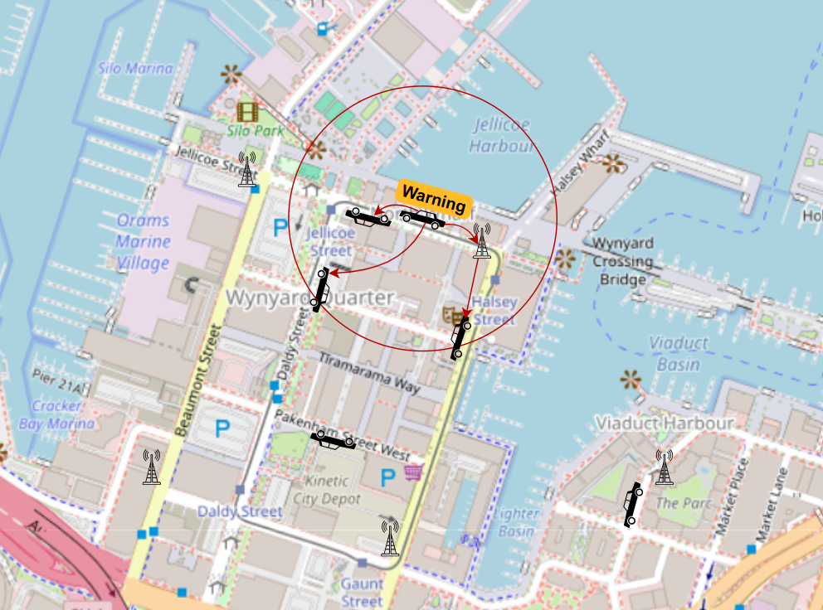
Figure 3.2: Illustration of emergency message propagation across an urban vehicular network with RSU-assisted awareness.
The figure highlights how an emergency event originating from a single vehicle propagates through opportunistic vehicle-to-vehicle communication, while RSUs act as local awareness anchors. The highlighted region represents the active emergency influence zone, within which vehicles exchange updates to maintain a consistent distributed awareness state despite intermittent connectivity.
Figure 3.3 provides a high-level operational view of the mobile node behaviour, capturing the repeated cycle of context acquisition, message activity, and adaptation driven by intermittent contact opportunities.
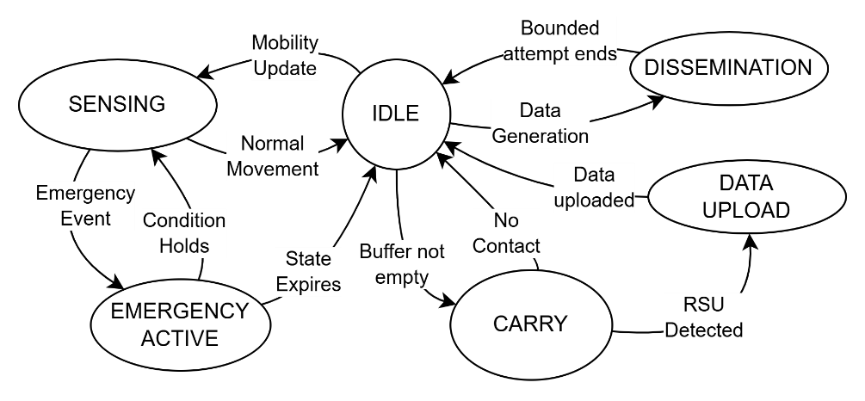
Figure 3.3: The high-level operational state machine.
The design deliberately remains lightweight and modular. BGKP is implemented as a minimal kernel of mechanisms required to support emergency dissemination under mobility, with the intention that additional features can be introduced later if needed. In the current scope, RSUs do not perform aggregation or backend integration, and mobile nodes do not require global state, route discovery, or central coordination. All protocol decisions are made locally, and communication progresses through opportunistic encounters rather than persistent end-to-end paths.
To support efficient dissemination under variable connectivity, nodes employ a lightweight peer selection strategy based on local interaction feedback. Rather than broadcasting uniformly to all neighbours, nodes maintain a small set of responsive peers identified through successful acknowledgement exchanges. This preferred peer set is used to bias retransmission decisions towards nodes that have recently demonstrated reliable communication, while still allowing opportunistic broadcast to maintain reachability under changing network conditions.
The selection mechanism remains fully local and adaptive, requiring no global knowledge or explicit neighbour discovery. This allows the protocol to balance redundancy and efficiency while operating under highly dynamic and fragmented connectivity.
The evaluation is organised as shown in Figure 3.4, around two mobility environments: an urban scenario and a highway scenario. Urban mobility is derived from a map-constrained traffic simulator (SUMO), while the highway scenario uses a simplified scripted mobility model in the network simulator (Cooja); implementation details are provided in Chapter 4. Across both environments, the experiments include a density sweep, where the number of mobile vehicles is varied from low to high (e.g., 10 to 100 vehicles) while preserving the scenario structure, so that emergency dissemination reliability can be examined as connectivity conditions change.
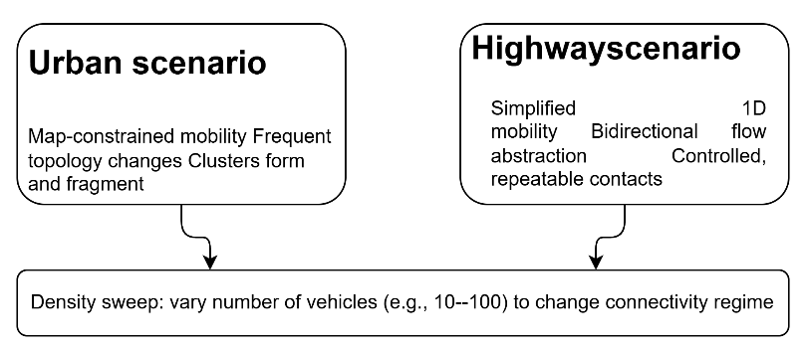
Figure 3.4: Two-scenario evaluation concept.
Emergency communication is modelled as a time-critical signal that is intended to remain visible to nearby vehicles despite transient fragmentation. The system adopts a state-based emergency notion: an emergency condition is not assumed to be captured by a single packet delivery, but rather by a short-lived awareness state that must become visible to surrounding nodes during the period when the hazard is relevant, as described in figure 3.5.
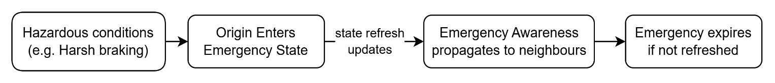
Figure 3.5: Emergency awareness as a state.
The emergency state persists as long as the triggering condition remains active at the originating node and is implicitly maintained through periodic updates. Once the condition is cleared, the absence of further updates causes the distributed awareness state to gradually decay across the network without requiring an explicit global lifetime constraint.
RSUs support this model in a minimal way by acting as local awareness anchors, while the mobile-to-mobile mechanism remains the primary dissemination path. The protocol is intentionally bare-minimum: it focuses on making emergency awareness propagate across encounters and remain robust to intermittent contacts, without assuming infrastructure ubiquity or continuous connectivity.
Under fragmentation, the system also requires that normal (non-emergency) data can tolerate delays without destabilising operation. To support this, the model includes bounded local storage at mobile nodes and opportunistic delivery to RSUs. Messages are retained across disconnections and released when contact opportunities occur, while memory use remains bounded through deterministic eviction. In the present implementation, eviction results in oldest message drop when storage is exhausted.
Overall, the system model emphasises two principles: first, emergency dissemination must remain reliable under dynamic connectivity by treating emergency awareness as a distributed state rather than a single transmission outcome; second, the protocol should remain lightweight and extensible, providing a minimal modular foundation that can be expanded later as requirements evolve.

Implementation
This chapter presents the design and operation of the proposed Bounded Gossip‑based Kernel Protocol (BGKP), focusing on the key ideas that enable stable and resource-bounded dissemination in highly dynamic vehicular ad hoc networks. The design is driven by the need to operate under prolonged network fragmentation, where persistent connectivity cannot be assumed and communication opportunities are intermittent.
At a high level, the system consists of mobile nodes representing vehicles and Roadside Units (RSUs) acting as intermittent infrastructure access points. Mobile nodes communicate opportunistically using broadcast transmissions, exchange information with nearby peers, and deliver data to RSUs when connectivity becomes available. This interaction model is illustrated conceptually in Figure 4.1.
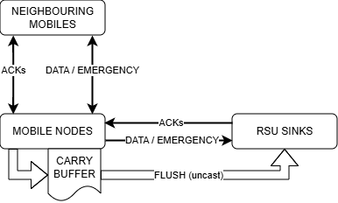
Figure 4.1: System overview and message flow.
The protocol operates without reliance on routing or global coordination. Instead, it follows a gossip-based dissemination approach, where messages propagate through local interactions between nodes. Each node makes forwarding decisions independently based on locally available information, allowing the system to adapt naturally to changes in connectivity and node density.
At runtime, a mobile node continuously cycles through three primary activities: sensing its local state, generating or propagating messages, and adapting its behaviour based on network feedback. This high-level control flow is represented in Figure 4.2.
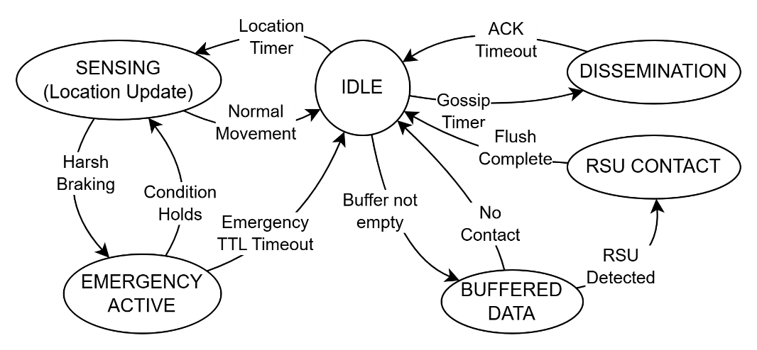
Figure 4.2: High-level operational state machine.
Mobility input plays a central role in the protocol. Each node obtains position and timing information through a UART-based interface that emulates a GPS-like sensor. In simulation, this sensor is implemented by a Cooja scenario script that responds to REQ_LOC requests, providing position and timestamp values derived from a mobility trace.
The core functionality of BGKP is built around two types of information: periodic DATA messages and event-driven EMERGENCY messages. DATA messages represent normal operational traffic and are disseminated using bounded gossip, while EMERGENCY messages represent time-critical conditions that require rapid propagation.
Under normal conditions, the node operates in an idle or steady-state mode, periodically transitioning into a dissemination state when triggered by internal timers. In this state, DATA messages are broadcast and may be retransmitted based on acknowledgement feedback within a bounded window. The detailed behaviour of this dissemination process, including retransmission logic and peer interaction, is described algorithmically in the pseudocode presented in Figure 4.3 and the operational flow of the dissemination process is illustrated in Figure 4.4.
Figure 4.3: Pseudocode of the Gossip dissemination process.
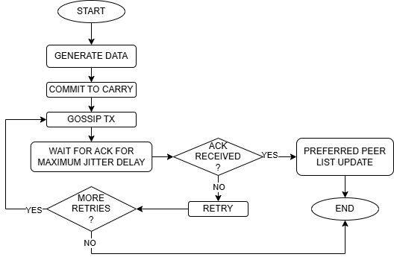
Figure 4.4: Gossip dissemination with bounded retry and preferred peer adaptation.
To maintain operation under intermittent connectivity, nodes employ a store-carry-forward strategy. Messages that cannot be delivered immediately are stored in a bounded local buffer and carried until new forwarding opportunities arise. The buffer operates under strict capacity limits, and an eviction mechanism ensures that system memory usage remains predictable. The buffer operation and eviction process are illustrated in Figure 4.5.
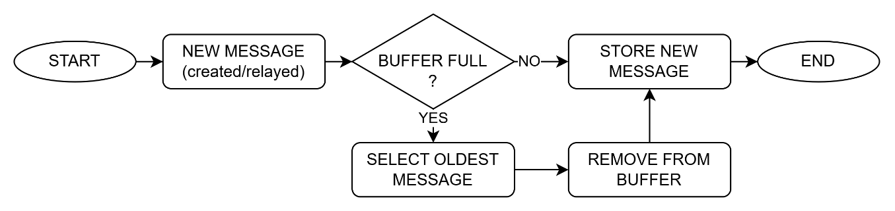
Figure 4.5: Carry buffer operation with eviction.
When an RSU is detected, nodes transition into an infrastructure interaction mode, in which buffered messages are delivered using unicast communication. Successful delivery is confirmed through acknowledgements, allowing corresponding entries to be removed from the buffer. This interaction mechanism separates opportunistic dissemination from reliable infrastructure delivery and is illustrated in Figure 4.6.
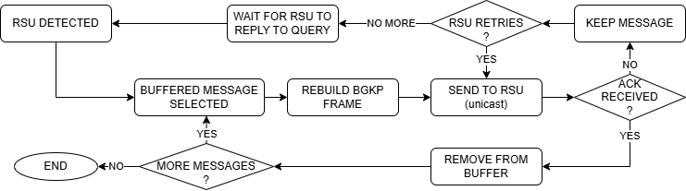
Figure 4.6: Opportunistic RSU flush with ACK-controlled buffer removal.
In addition to periodic data dissemination, BGKP incorporates support for emergency event propagation. Emergency events are detected locally based on mobility-derived signals, specifically abrupt deceleration associated with harsh braking. A threshold-based detection mechanism is used, with a threshold of approximately 3.0 m/s², consistent with empirical observations reported in prior work [17].
Once this condition is detected, the node transitions into an active emergency state. The behaviour of this state is illustrated in the emergency sub-state machine shown in Figure 4.7.
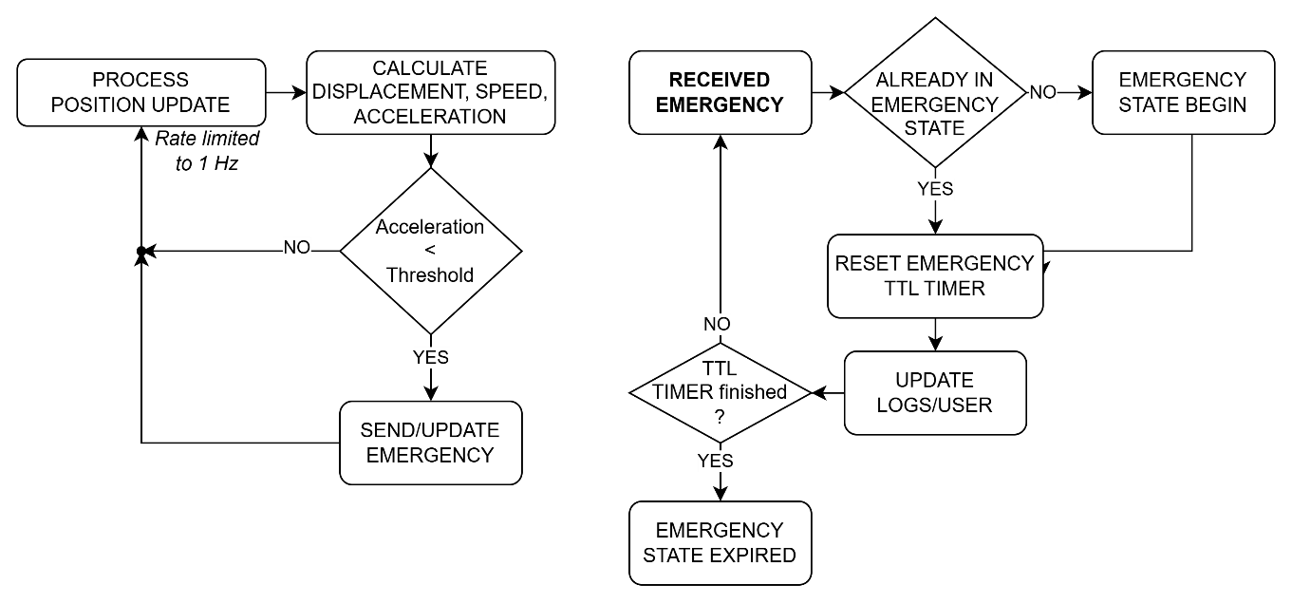
Figure 4.7: Emergency sub-state machine.
Rather than transmitting a single notification, the protocol maintains an active emergency state through periodic updates while the triggering condition remains valid. This behaviour follows the update-while-trigger-valid model [18], where multiple EMERGENCY messages correspond to a single logical event and collectively represent a transient distributed state.
This approach improves robustness under intermittent connectivity, ensuring that nodes entering the affected area can obtain the current emergency state without relying on a single transmission.
In parallel, DATA dissemination is performed using bounded gossip with adaptive control. A key component of this mechanism is the preferred peer selection strategy, described in Chapter 3 and illustrated in Figure 4.8. Nodes maintain a small set of responsive peers based on observed acknowledgements, biasing retransmissions towards reliable neighbours while limiting unnecessary redundancy.
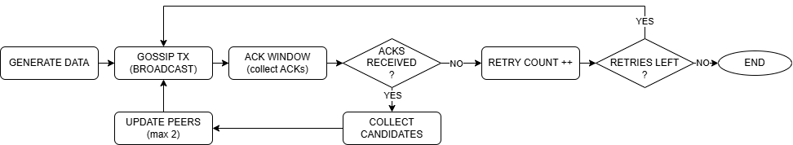
Figure 4.8: Preferred peer selection within the gossip dissemination cycle.
Together, state-based emergency propagation and adaptive gossip dissemination enable stable and predictable behaviour under highly dynamic and fragmented network conditions.
In addition to mobile node behaviour, the protocol includes a minimal infrastructure component in the form of Roadside Units (RSUs), which act as opportunistic data sinks and local dissemination amplifiers. The RSU logic is intentionally simple, reflecting the design goal of isolating dissemination behaviour from infrastructure complexity.
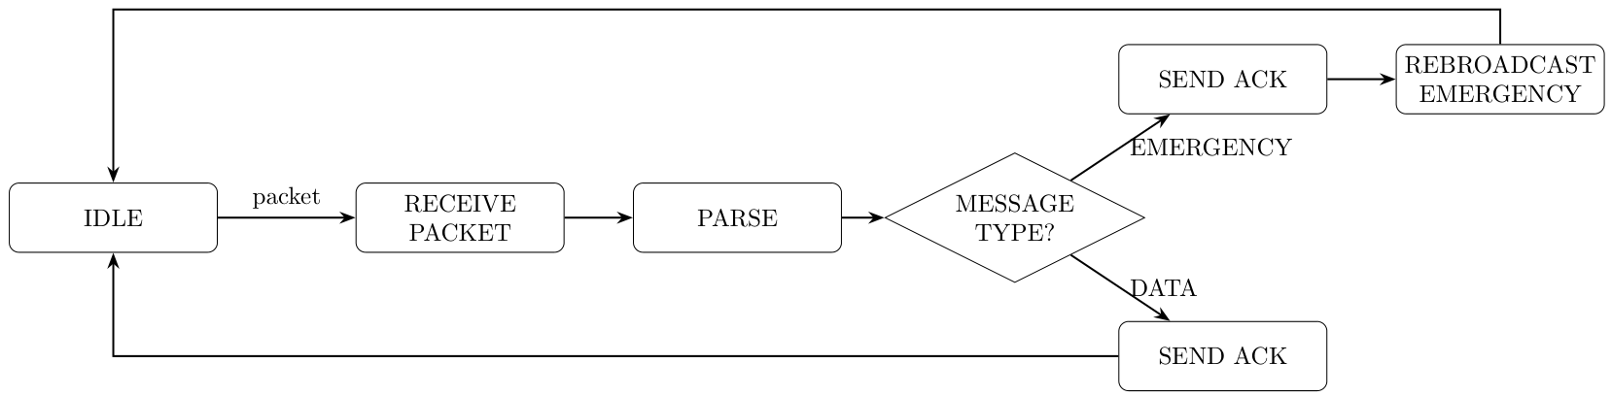
Figure 4.9: State machine for Roadside Unit logic.
Upon receiving a packet, the RSU parses the message and determines its type. For DATA messages, a direct acknowledgement is returned to the sender. For EMERGENCY messages, the RSU sends an acknowledgement and performs a single local rebroadcast, introducing the emergency state into its coverage area.
In addition, acknowledgement messages carry an Emergency Flag indicating the presence of an active emergency state. This allows newly arriving nodes to become aware of ongoing emergency conditions through interaction with the RSU, even if no direct broadcast is received.
Beyond this local rebroadcast and flagged acknowledgements, the RSU does not participate in ongoing dissemination. Emergency propagation is maintained by mobile nodes through the state-based update mechanism. The RSU does not generate data, perform aggregation, or enforce time-to-live constraints. All lifetime management is handled by mobile nodes, ensuring consistent behaviour across infrastructure-assisted and purely opportunistic communication.
Combined, these mechanisms define a protocol that integrates gossip-based dissemination, bounded resource usage, and state-based emergency propagation, enabling stable and predictable operation under highly dynamic and fragmented network conditions.
The protocol defines a small set of message types that support the core dissemination behaviour. These include DATA, EMERGENCY, QUERY, and ACK messages, each serving a specific role within the system.
All messages in BGKP follow a unified frame structure, allowing consistent processing across different message types. The structure of the BGKP frame is shown in Table 4.1.
Field | Size(Bytes) | Description
Marker | 4 | Protocol identifier ("BGKP")
Length | 3 | Frame length
Sender ID | 4 | Physical sender identifier
Message Type | 1 | DATA, EMERGENCY, QUERY, or ACK
Message ID | 4 | Unique message identifier
Target ID | 4 | Intended destination or broadcast
Origin ID | 4 | Original message creator
Payload | Variable | Message‑specific payload
Timestamp | 4 | Creation time (ms)
Checksum | 1 | Simple frame checksum
Table 4.1: BGKP Frame Structure.
Each message contains identifying information, including sender and origin identifiers, a message type field, and a timestamp used for ordering and evaluation. A lightweight checksum is included to ensure message integrity.
Message-specific information is encoded within the payload, which varies depending on message type. The payload definitions are summarised in Table 4.2.
Payload Type | Fields (summary) | Purpose
DATA | Position, speed, direction, TTL, peers | Periodic mobility data dissemination
EMERGENCY | Event code, position, speed, direction | Harsh-braking event notification
QUERY | Node identifier, emergency flag (summary) | Presence announcement and state exchange
ACK | Acknowledged message metadata, emergency flag | Reception confirmation
Table 4.2: BGKP Payload Types.
While the message format defines how information is structured and exchanged between nodes, the behaviour observed in simulation is shaped by the mobility environment that determines when and where nodes come into radio contact. In this work, mobility is produced using two complementary approaches: a trace-driven urban workflow generated externally with SUMO, and a script-driven highway workflow generated internally within Cooja.
For the urban scenario, road network topology is obtained from OpenStreetMap [16] and used to prepare a working traffic network for trace generation. The resulting network is reviewed and refined in netedit before vehicle trajectories are generated and exported as time-indexed XML traces. These traces are then processed by a dedicated Python conversion script, which transforms SUMO trajectories into a format compatible with the Cooja Mobility Tool, while preserving node identifiers and timing information.
During Cooja execution, the converted mobility trace is not consumed directly by the BGKP protocol. Instead, a Cooja scenario script emulates a GPS-like sensor via the UART interface: mobile nodes periodically issue REQ_LOC requests, and the script responds with position and timestamp values synchronised with simulation time. This mechanism supplies the node’s internal mobility readings in a consistent way across scenarios and keeps the protocol logic independent of the mobility source.
The overall integration flow, including map preprocessing, mobility generation, trace conversion, and runtime injection, is illustrated in Figure 4.10, which highlights the interaction between SUMO and Cooja components and their role in the experimental pipeline.
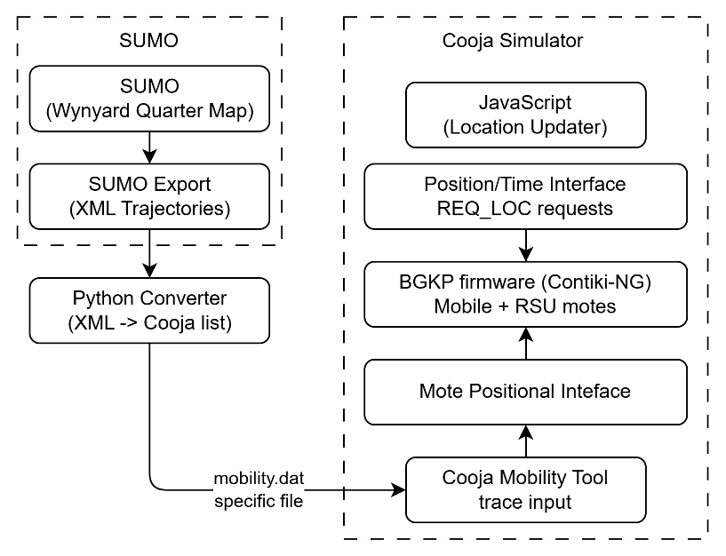
Figure 4.10: SUMO-Cooja mobility integration pipeline.
The step-by-step procedure used to export map data, generate mobility traces in SUMO, convert those traces for Cooja, and inject them at runtime is given in Appendix A. The procedure used to generate Cooja scenario files and execute the simulations in headless mode is given in Appendix B.
The resulting mobility representation is further visualised in Figure 4.11, showing the correspondence between the real-world road layout and its simplified simulation equivalent, with node placement and trajectories overlaid to demonstrate how spatial structure translates into network connectivity conditions.
a)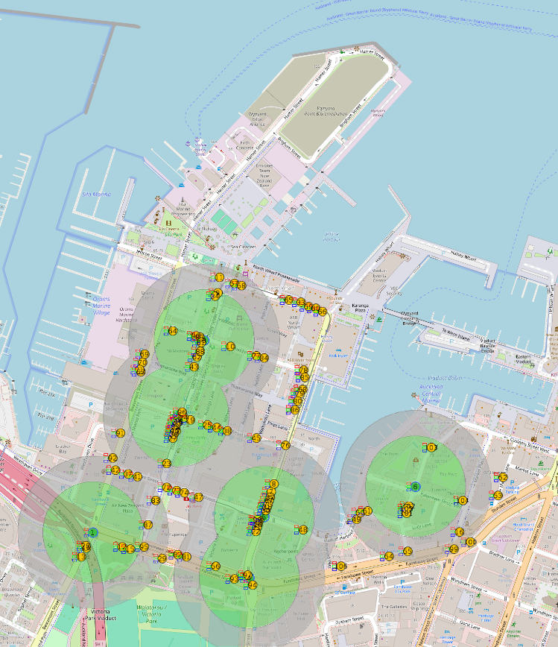 b) 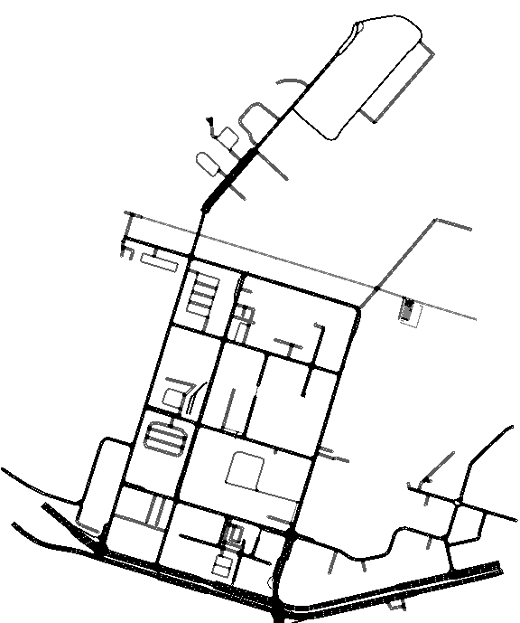
Figure 4.11: Urban simulation scenario based on Wynyard Quarter - (a) Map with nodes and RSUs, (b) SUMO schematic representation
Implementation-level details of message generation and node behaviour remain independent of this pipeline and are driven solely by the injected mobility data, ensuring that evaluation results reflect protocol behaviour rather than artefacts of the mobility interface.
In contrast to the trace-driven urban scenario, highway mobility is generated directly within the Cooja simulation environment using a simplified script-based model. This approach provides a controlled and reproducible mobility environment without relying on external map data or complex road geometry.
Nodes are divided into stationary and mobile groups, with stationary nodes placed at fixed positions and mobile nodes distributed along a linear path. Mobile nodes move continuously along this path with opposing traffic directions, approximating bidirectional vehicle flow on a highway.
Movement is updated periodically during simulation, with nodes traversing the defined space and reversing direction at the boundaries, as illustrated in Figure 4.12. This produces continuous interaction between nodes while maintaining a simple and deterministic mobility pattern.
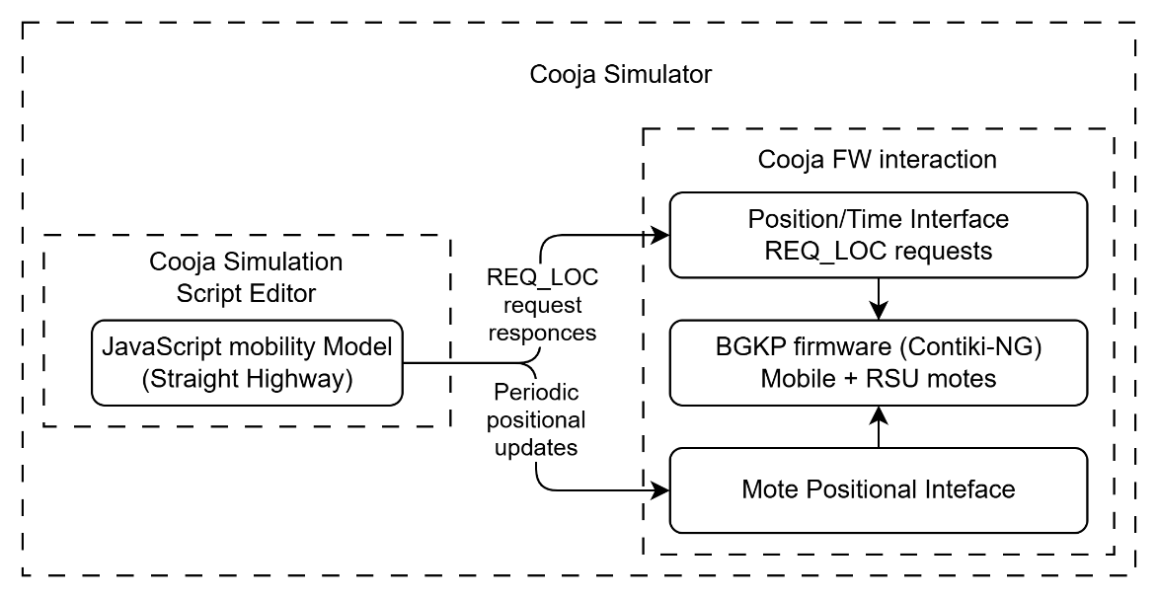
Figure 4.12: Highway mobility integration in Cooja.
Mobility updates are exposed to the protocol through the same UART-based REQ_LOC interface used in the urban scenario, ensuring consistent handling of position data across all experiments. The structure of the highway mobility model is illustrated in Figure 4.13.
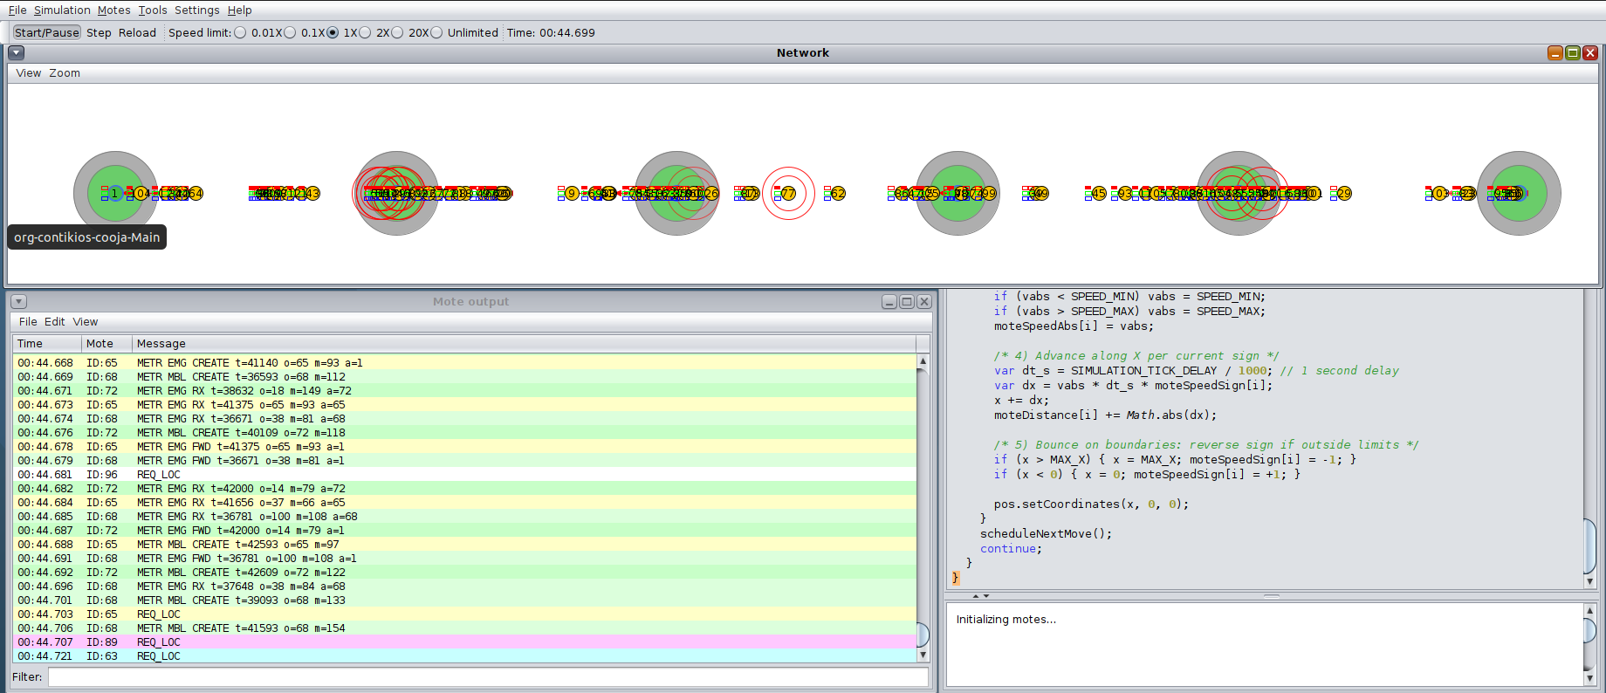
Figure 4.13: Script-based highway mobility model showing node placement, bidirectional movement, and periodic coordinate updates
The implementation of BGKP focuses on capturing the core dissemination behaviour under controlled and reproducible conditions, and therefore intentionally excludes several aspects that are not central to the objectives of this work. In particular, the system does not incorporate mechanisms for authentication, security, or protection against malicious nodes, and does not model interactions with backend services beyond RSU-based message collection. The communication model relies on an abstracted IEEE 802.15.4 radio environment provided by the simulator, without attempting to reproduce detailed physical-layer effects such as fading, shadowing, or interference beyond the built-in model.
Similarly, the mobility environment prioritises controllability and repeatability over full realism. While the urban scenario is derived from real-world map data, the highway scenario uses a simplified script-driven model that abstracts vehicle motion to a one-dimensional flow. These choices allow systematic experimentation across different densities and connectivity conditions, while ensuring that observed behaviour is attributable to protocol design rather than environmental complexity.
Resource behaviour is also intentionally constrained. Nodes operate with bounded buffers, simplified timing mechanisms, and limited local state, reflecting the intended deployment on resource-constrained platforms. At the same time, higher-level considerations such as energy modelling, duty cycling, and hardware-specific optimisation are not included in the current implementation.
These design constraints align the implementation with the primary goal of the study, which is to analyse the stability and bounded behaviour of gossip-based dissemination under fragmentation, as well as the reliability of the protocol in propagating emergency notifications under dynamic and intermittent connectivity conditions, rather than to replicate a fully detailed vehicular communication stack. As a result, the implementation provides a controlled environment in which protocol behaviour can be observed and evaluated without interference from unrelated system components.
Several additional design extensions were considered during the development of the protocol but were not implemented within the scope of this work. These include support for multiple emergency types (e.g., collision, slow traffic, hazard reporting), improvements to carried data management through more advanced buffer retention strategies, and further refinement of the peer selection mechanism, including adaptive filtering and prioritisation strategies to improve the identification and retention of reliable peers under dynamic network conditions. While these features could enhance the applicability of the protocol, they were deferred in order to maintain a focused evaluation of the core dissemination behaviour.
To complement the simulation-based evaluation, a preliminary hardware realisation of the BGKP system was implemented using SimpleLink CC1352R LaunchPad boards. The objective of this stage was not to reproduce the full experimental scenarios, but to verify that the protocol can be successfully deployed and executed on real embedded hardware under constrained conditions.
The hardware setup consisted of two physical nodes, configured to emulate a minimal mobile - RSU interaction. Two boards were operating as a mobile nodes, while the third board was configured as an RSU. All devices were programmed with the same Contiki‑NG-based firmware used in the simulation environment, ensuring consistency between simulated and physical execution environments. Communication between the nodes was established over IEEE 802.15.4 using the SimpleLink radio, while UART was used for logging and observation of system behaviour via a serial interface.
The system was structured to follow the same operational principles as in simulation. The mobile nodes periodically generated protocol messages, including QUERY and DATA frames, and transmitted them opportunistically. Upon reception, the RSU node performed message parsing and generated acknowledgements, including optional emergency state flags when applicable. All protocol interactions were recorded through UART output, providing a direct observation channel of message exchange, acknowledgement handling, and protocol state transitions.
The intended scope of hardware validation included several fundamental functional checks. These included verification of firmware execution and system stability after deployment, confirmation of wireless communication between nodes, correct operation of the acknowledgement mechanism, and basic validation of emergency signalling behaviour. The goal was to ensure that the protocol logic implemented in simulation is transferable to a real embedded environment without fundamental incompatibilities.
Due to the limited availability of external hardware components, in particular the absence of a GNSS module during the testing phase, certain parts of the system were not exercised. Specifically, the location acquisition subsystem, which is responsible for providing position and timing data via a UART interface, was not active in the hardware setup. As a consequence, mobility-dependent features, including movement-based behaviour and harsh braking detection for emergency triggering, were not evaluated in the real-world tests. The hardware validation therefore focuses on communication correctness and system integration, rather than full behavioural reproduction of the simulated scenarios.
Despite these limitations, the hardware realisation provides an important proof that the BGKP system can operate on constrained embedded platforms and that its core communication mechanisms function as intended outside the simulation environment.

Experiments and Results
This chapter describes the experimental procedure used to evaluate BGKP and presents the obtained results. All experiments are performed in the Cooja simulator with Contiki-NG firmware, where each mobile node runs the same BGKP application and communicates over IPv6/6LoWPAN using UDP on the IEEE 802.15.4 radio model provided by the simulator. The mobility environment is treated as a controlled experimental input that determines when and where nodes come into radio contact; the mobility generation and injection mechanisms are implemented as described in Chapter 4.
For comparative evaluation, two baseline dissemination strategies are considered: a flooding-based broadcast protocol (FLUD - Flooding UDP baseline) and a minimal unicast-based scheme (DUMB - Direct Unicast Minimal Beaconing). FLUD periodically generates DATA messages at the mobile nodes and rebroadcasts newly received packets until a fixed hop limit is reached, using a small local seen-message table for duplicate suppression. The same message structure is also used for EMERGENCY records, which are generated locally from motion-derived events and then propagated through the same hop-limited flooding mechanism, while the RSU acts only as a receiver for metric extraction. DUMB uses the same UART-based location interface as BGKP, carries motion-related fields in its messages, maintains a compact carry buffer for opportunistic RSU delivery, and forwards DATA through bounded retries with a small acknowledgement-based peer set. Emergency messages are generated separately from local motion events, while the RSU acknowledges all received packets, rebroadcasts each received emergency once, and includes a compact indication of the latest emergency state in outgoing acknowledgements. These serve as reference points to assess the trade-offs introduced by the proposed BGKP protocol.
The overall execution pipeline for experiments is illustrated in Figure 5.1, showing how scenario configuration and mobility inputs lead to simulation execution, how protocol events are recorded as logs, and how the logs are post-processed into quantitative metrics.
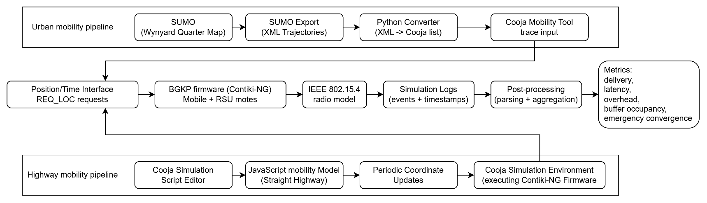
Figure 5.1: Modeling Environment.
The evaluation is conducted across representative connectivity regimes designed to exercise both frequent-contact behaviour and prolonged fragmentation. The urban scenario is based on the Wynyard Quarter environment, providing a dense deployment with realistic spatial constraints.
To evaluate performance under different connectivity conditions, multiple traffic configurations are executed by varying the number of mobile nodes while keeping the scenario definition consistent. This enables systematic comparison across low-density and high-density settings (e.g., 10 to 100 vehicles), where contact frequency, cluster sizes, and RSU encounter opportunities differ.
The evaluation focuses on the following performance metrics:
- packet delivery ratio (PDR)
- end-to-end latency
- transmission overhead
- buffer behaviour
- emergency convergence (t50, t90, t99)
During each simulation run, protocol-level activity is recorded as text logs. These logs include message creation and reception markers, transmission counters per message type, acknowledgement activity, RSU delivery confirmation events, carry-buffer dynamics, and emergency-related event markers required to quantify emergency notification dissemination. The logs are processed after the run to compute the performance metrics reported in this chapter. For consistency, all simulation logs were collected into a common output directory and processed using a single batch-oriented post-processing workflow. Final performance metrics were extracted from the log records using a custom Python script, which computed delivery, latency, overhead, buffer, and emergency-dissemination statistics for each run. The resulting batch summary log was then parsed by another Python script to produce the comparative plots and CSV summaries used in this report. A detailed description of the log-processing and plotting workflow is provided in Appendix C.
Packet delivery ratio (PDR) is computed as the fraction of created messages that are successfully delivered to an RSU. End-to-end latency is measured as the time elapsed between message creation at the originating node and successful delivery at an RSU. Transmission overhead is computed as the total number of protocol transmissions per delivered message, providing a direct measure of channel and protocol cost. Buffer behaviour is reported through occupancy statistics and buffer event counters, reflecting store-carry-forward operation under disconnection. Figure 5.2 presents an example of a metrics log taken out of a ~100k lines log, created during a simulation of 100 mobile motes.
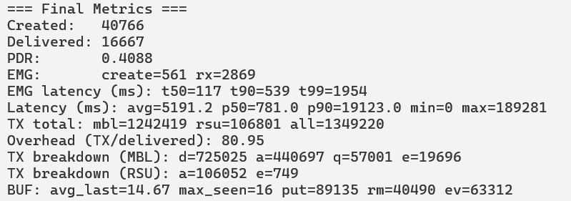
Figure 5.2: Example of parser script output with metrics for an Urban scenario with 100 vehicles.
Each evaluated protocol (BGKP, FLUD, and DUMB) is executed under identical simulation conditions, allowing direct comparison of delivery performance, communication cost, and emergency dissemination behaviour.
The main quantitative results are summarised in Table 5.1 and in the density-dependent plots that follow. Each reported point corresponds to a completed run under a specific scenario and node density, enabling direct comparison across protocols and connectivity regimes.
Representative low-, medium-, and high-density points are shown in the tables for compact comparison, while the complete density sweeps are presented in the figures that follow.
Mobile count | 10 |  |  | 50 |  |  | 90
Protocol | Flooding | DUMB | BGKP | Flooding | DUMB | BGKP | Flooding | DUMB | BGKP
Packet Delivery Ratio | 0.3088 | 0.3822 | 0.658 | 0.334 | 0.191 | 0.451 | 0.346 | 0.184 | 0.427
Average Data Latency (ms) | 260.4 | 285.4 | 14618.5 | 282.7 | 334.1 | 8017.3 | 462.1 | 340.1 | 5303.4
Overhead (TX/Delivered) | 5.6 | 8.62 | 69.22 | 31.7 | 13.92 | 92.38 | 60.55 | 15.25 | 79.55
EMG t50 (ms) | 250 | 78 | 86 | 54 | 141 | 235 | 47 | 211 | 453
EMG t90 (ms) | 312 | 336 | 282 | 242 | 531 | 641 | 304 | 602 | 1296
EMG t99 (ms) | 414 | 578 | 415 | 500 | 820 | 1227 | 609 | 914 | 3687
Table 5.1: Comparative performance of dissemination protocols in Urban environment.

Mobile count | 10 |  |  | 50 |  |  | 100
Protocol | Flooding | DUMB | BGKP | Flooding | DUMB | BGKP | Flooding | DUMB | BGKP
Packet Delivery Ratio | 0.1218 | 0.3934 | 0.7032 | 0.1752 | 0.475 | 0.2992 | 0.2811 | 0.3429 | 0.2566
Average Data Latency (ms) | 271.7 | 350.6 | 16021.4 | 308.6 | 289.7 | 6390.2 | 354.9 | 329.4 | 4350.7
Overhead (TX/Delivered) | 10.69 | 10.16 | 539.74 | 25.66 | 8.38 | 204.14 | 37.03 | 11.26 | 186.28
EMG t50 (ms) | 234 | 94 | 164 | 117 | 226 | 305 | 70 | 344 | 383
EMG t90 (ms) | 531 | 164 | 586 | 336 | 680 | 797 | 273 | 852 | 1023
EMG t99 (ms) | 711 | 265 | 618 | 672 | 922 | 1985 | 617 | 1211 | 2539
Table 5.2: Comparative performance of dissemination protocols in Highway environment.
To further illustrate the observed behaviour, the comparative results are presented as density-dependent trend plots for both the urban and highway scenarios. These plots show that the protocols exhibit different trade-off profiles: BGKP tends to favour delayed RSU delivery in the urban setting, whereas the simpler baselines often retain lower latency, lower absolute communication cost, and faster emergency convergence.

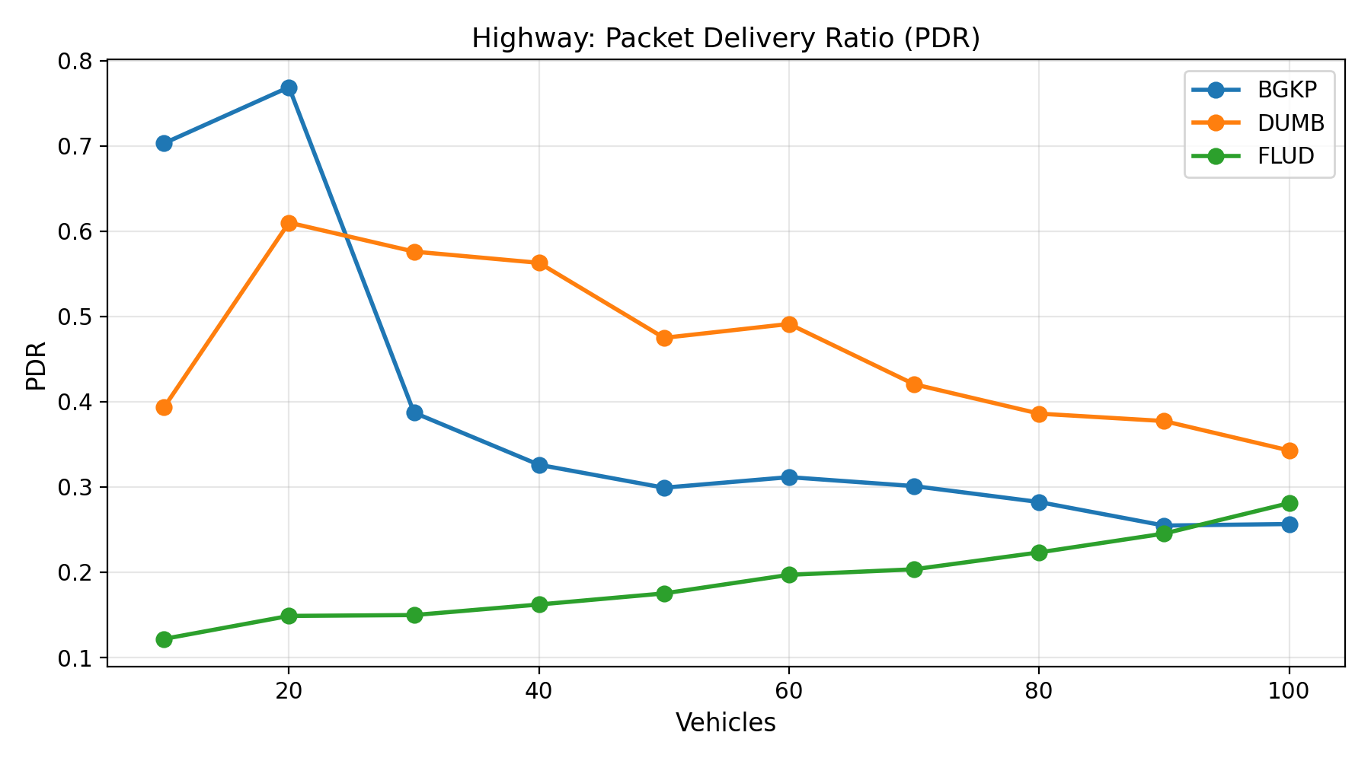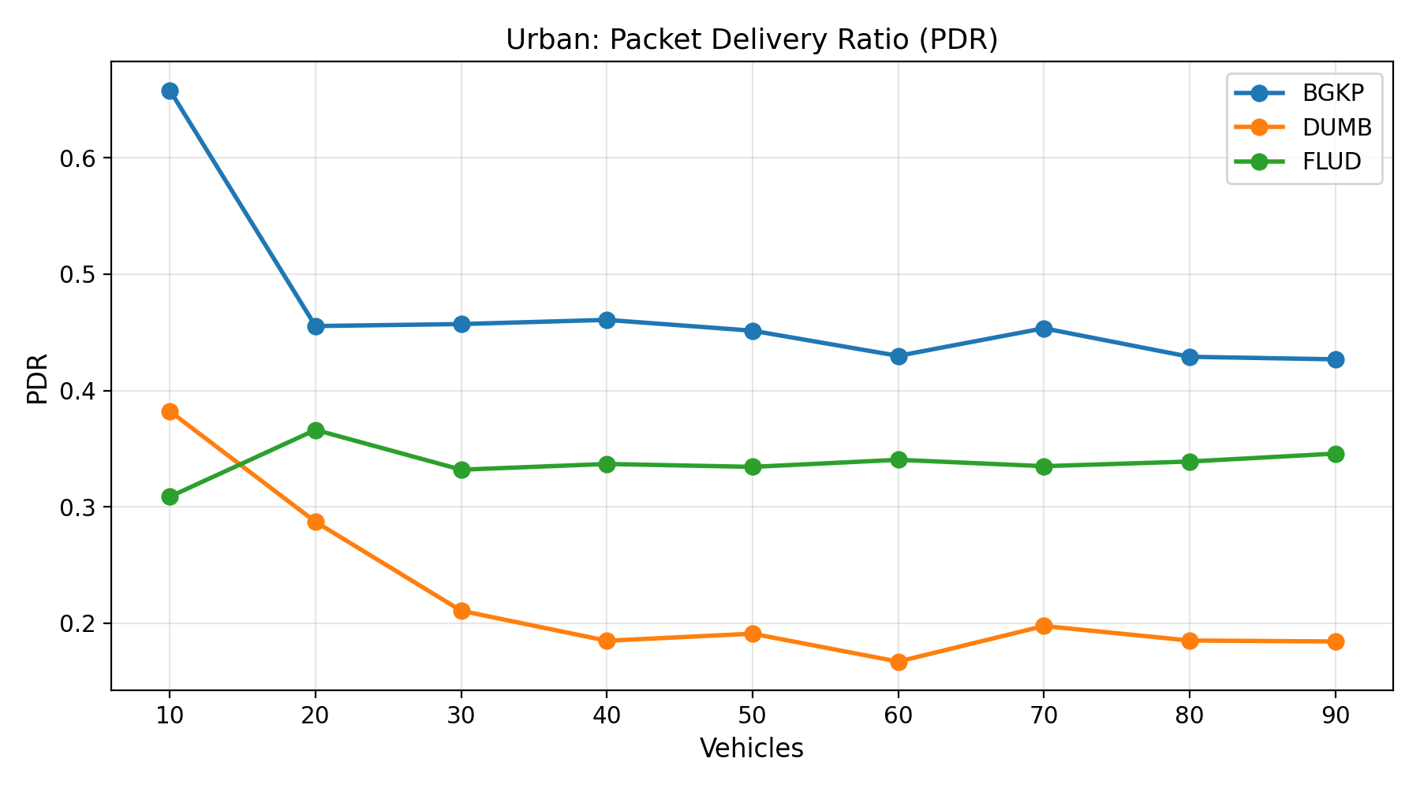
Figure 5.3: Packet delivery ratio (PDR) as a function of node density.
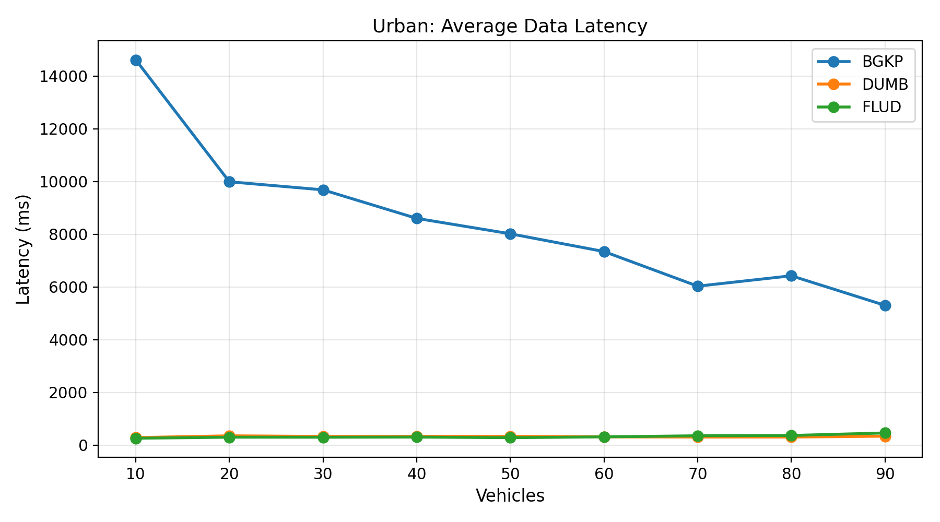
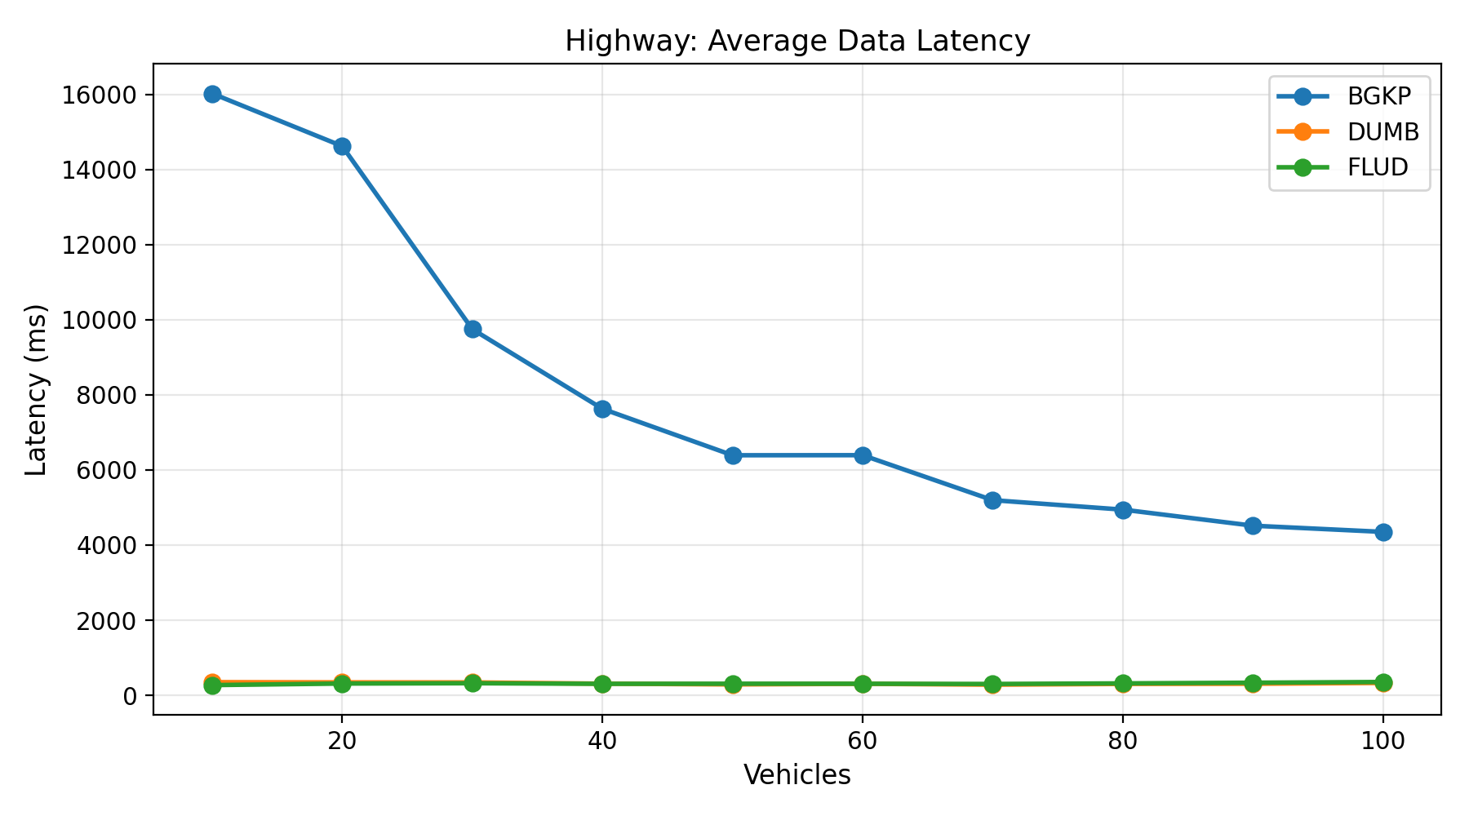
Figure 5.4: End-to-end data latency as a function of node density.
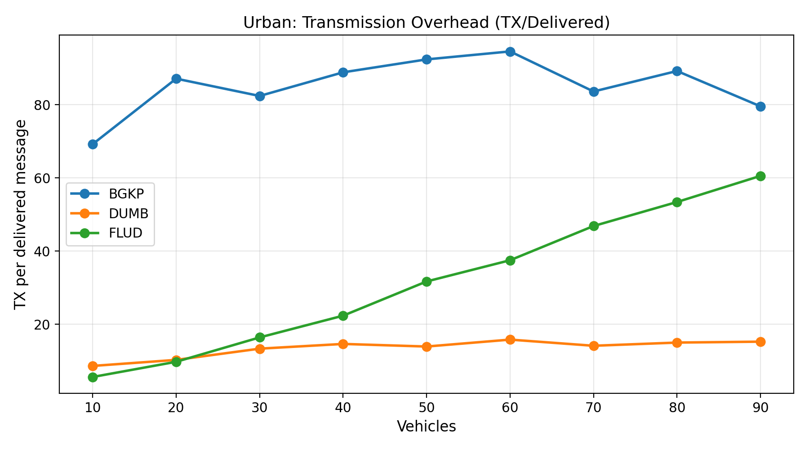
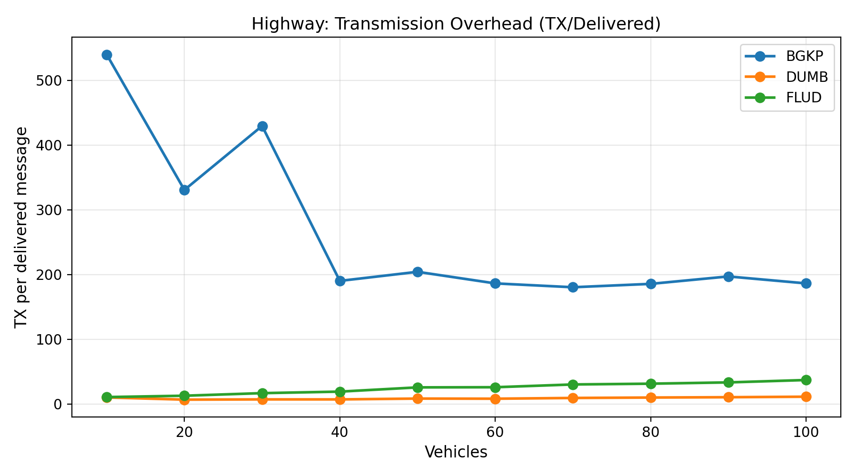
Figure 5.5: Transmission overhead as a function of node density in Urban scenario.
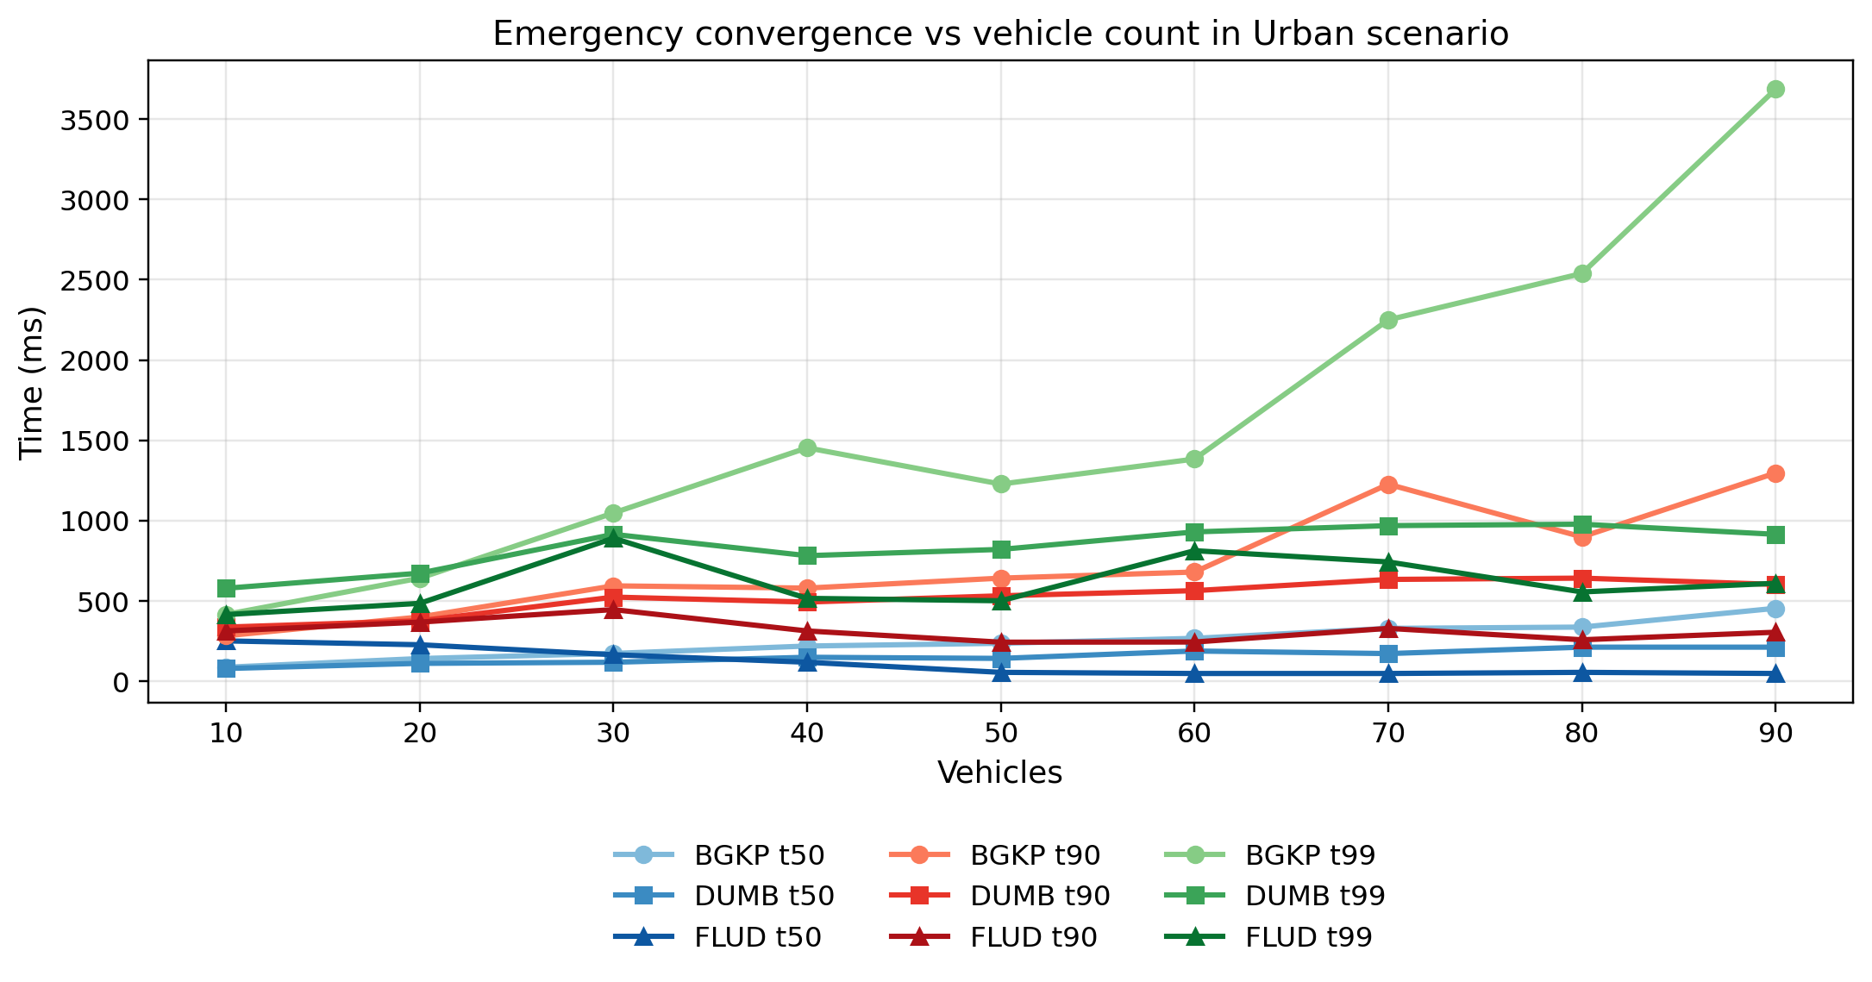
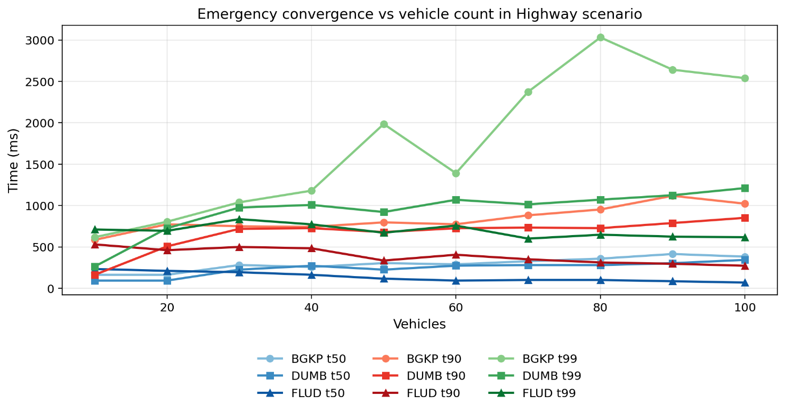
Figure 5.6: Emergency convergence as a function of mote density in the Urban scenario.
Taken together, the figures show that the relative behaviour of the evaluated protocols depends strongly on the scenario. In the urban case, BGKP maintains the highest RSU-delivered data ratio across the tested densities, but this is accompanied by substantially higher latency and higher absolute transmission overhead. In the highway case, the same advantage does not persist beyond the lowest densities, while the simpler baselines often retain lower latency and faster emergency convergence.
Interpretation of these results is presented in Chapter 6 (Discussion).
The preliminary hardware validation confirmed that the BGKP implementation operates correctly on the deployed embedded platform. During testing, the RSU node successfully received incoming DATA and QUERY messages transmitted by the mobile nodes and generated corresponding acknowledgement responses. All interactions were observable through the UART interface, where the RSU log consistently reported received message identifiers and acknowledgement activity via the serial (COM port) output.
The communication exchange between nodes remained stable throughout the test runs, with no observed protocol-level failures such as missed acknowledgements or malformed frames. The system demonstrated correct end-to-end message handling, including transmission, reception, parsing, and response generation, indicating that the implemented protocol behaviour is preserved when executed on physical hardware.
It should be noted that this validation is limited to functional behaviour and does not represent a quantitative performance evaluation. Due to the absence of GNSS input, the tests did not include location-aware operation or mobility-driven features such as harsh braking detection and emergency state generation. As a result, the hardware results are focused on confirming system integration and runtime correctness rather than assessing dissemination performance metrics.

Discussion
The results show a scenario-dependent trade-off rather than a uniform advantage for BGKP. In the urban scenario, BGKP consistently achieves the highest RSU-delivered data ratio across the evaluated densities, whereas in the highway scenario this advantage is limited to the lowest-density cases. The behaviour of the protocol therefore depends strongly on the connectivity regime, and the results should be interpreted in terms of trade-offs rather than overall superiority.
In the urban scenario, BGKP maintains the highest packet delivery ratio across all evaluated densities, ranging from 0.658 at 10 vehicles to 0.4268 at 90 vehicles. This advantage is obtained at a substantial cost in delivery delay: BGKP latency remains in the multi-second range throughout the urban sweep, while DUMB and FLUD stay in the range of a few hundred milliseconds. The urban results therefore indicate that BGKP favours eventual RSU delivery over low-delay transport.
This behaviour is consistent with observations in epidemic dissemination studies, where increased redundancy improves delivery probability at the cost of latency and overhead [8,15]. Bounded gossip and preferred-peer retransmission allow messages to continue propagating under intermittent contact, while carry buffering preserves undelivered data until an RSU encounter occurs. These mechanisms increase the likelihood of eventual RSU delivery, but they also introduce waiting time and additional transmissions, so the same design that raises the delivery ratio also produces substantially higher latency and higher communication cost.
The highway results reveal a different operating regime. At the two lowest densities, BGKP achieves the highest packet delivery ratio, but this advantage disappears once density increases. From 30 vehicles onward, DUMB provides a higher RSU-delivered data ratio, while FLUD generally retains the fastest emergency convergence. This indicates that the mechanism combination used by BGKP is more favourable to delayed urban delivery than to the highway settings evaluated in this study.
Communication cost must be interpreted carefully because the relative and absolute views differ. In the urban scenario, BGKP overhead varies more moderately with density than FLUD, but its absolute transmission cost remains substantially higher than both baselines at all evaluated points. In the highway scenario, BGKP overhead decreases as density increases, but it still remains far above the corresponding DUMB and FLUD values. The results therefore support the claim of more stable cost evolution relative to flooding, but not a claim of low or efficient overhead in absolute terms. Similar trade-offs between redundancy, delivery probability, and overhead have also been reported in epidemic routing literature [15].
The very high BGKP overhead observed at 10 vehicles in the highway scenario is consistent with this mechanism combination. Under such sparse conditions, nodes may remain disconnected for long periods, carry buffered data for extended intervals, and perform repeated dissemination attempts before any RSU delivery is achieved. When the number of successfully delivered messages remains small, the transmission-per-delivered-message ratio becomes especially large, producing the extreme overhead value observed at the lowest highway density.
Emergency dissemination results do not show systematic superiority of BGKP. In the urban scenario, BGKP is not the fastest protocol for emergency convergence beyond the lowest-density edge cases, and in the highway scenario FLUD generally achieves the lowest t50, t90, and t99 values across the evaluated range. This aligns with prior work showing that flooding-based approaches often achieve faster initial dissemination due to aggressive rebroadcasting [6]. The main observable strength of BGKP in the present study is therefore improved RSU-delivered periodic data in the urban fragmented case rather than faster emergency dissemination.
A limitation of the current highway emergency evaluation is that emergency events may be concentrated near the turning boundaries of the scenario, which are also close to RSU locations. In such cases, emergency awareness can be influenced strongly by immediate RSU-assisted dissemination rather than by purely vehicle-to-vehicle propagation. This reduces the ability of the highway scenario to isolate protocol performance in infrastructure-poor regions and may under-represent situations in which multi-hop mobile dissemination would have a larger impact.
Within the urban BGKP runs, the measured emergency t50 increases with node density, as shown in Figure 6.1. One possible explanation is that increasing aggregate channel activity introduces additional contention and medium-access delay, so that the growth in available forwarding opportunities does not translate directly into faster median convergence. This interpretation should be treated cautiously, however, because the measured percentile also depends on the spatial distribution of receivers and on the interaction between emergency traffic and the underlying periodic data load.
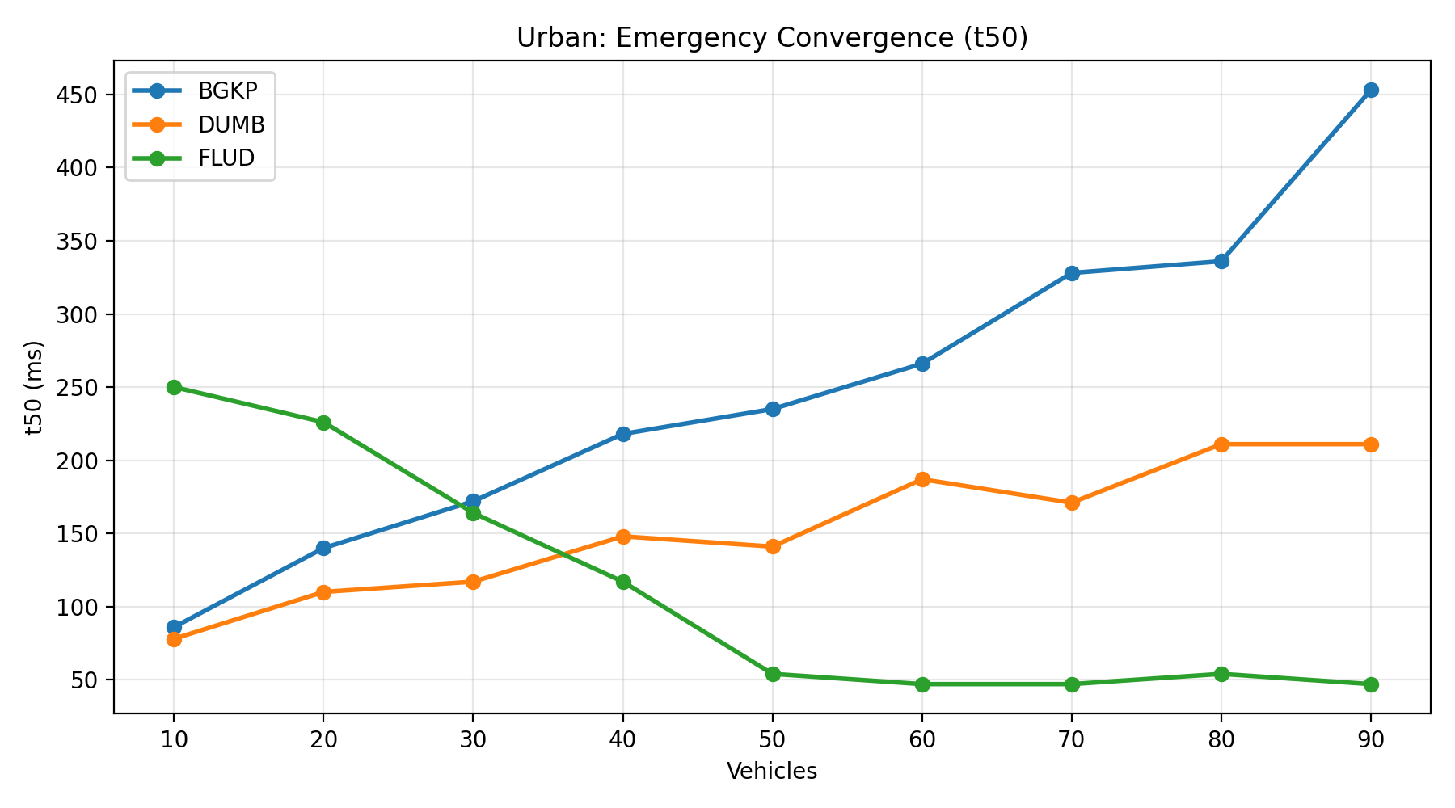
Figure 6.1: BGKP Emergency convergence to 50% of the vehicles in Urban environment
The discussion in this chapter uses the complete set of available urban and highway runs included in the final result summaries: 10-90 vehicles for the urban scenario and 10-100 vehicles for the highway scenario. These ranges are used consistently in the comparative interpretation that follows.
A further limitation is that the present evaluation uses a single completed run for each scenario-protocol-density combination and therefore does not quantify run-to-run statistical variance. The mobility inputs themselves are controlled once generated, since the urban traces are prepared externally and the highway case follows a scripted movement model, but repeated runs would still be required to characterise the variability of the measured metrics under alternative execution conditions. Extending the evaluation to multiple repetitions per configuration remains an important direction for future work.
Although BGKP improves comparative RSU-delivered data ratio in the urban scenario, the absolute PDR values observed in this study remain well below what would be expected of a deployable safety-critical communication system. The present work should therefore be interpreted as a simulation-based investigation of protocol behaviour and trade-offs rather than as evidence of suitability for production V2X deployment.
Overall, the results provide partial support for the bounded-behaviour objective of the protocol, but they do not demonstrate a general performance advantage over the simpler baselines. BGKP is best understood as a trade-off design: it can improve RSU-delivered data ratio in the urban fragmented scenario, but this benefit is accompanied by substantially higher latency, higher absolute communication cost, and no consistent emergency-convergence advantage.
In addition to the simulation-based evaluation, a preliminary hardware validation was conducted to confirm the implementability of the proposed system. While this validation does not provide quantitative performance metrics, it demonstrates that the BGKP protocol can be successfully deployed and executed on constrained embedded hardware, with correct message exchange and acknowledgement handling observed in practice.
This observation supports the feasibility of the protocol from an implementation perspective, although it does not alter the simulation-based findings regarding performance trade-offs, such as increased latency and communication overhead. The hardware results therefore complement the simulation study by confirming system operability rather than performance superiority.

Conclusion and Future Work
This work investigated emergency message dissemination in vehicular ad hoc networks under prolonged fragmentation through the design and evaluation of the Bounded Gossip-based Kernel Protocol (BGKP). The protocol combines adaptive gossip-based forwarding, bounded retransmission, store-carry-forward buffering, and state-based emergency propagation in order to study the trade-offs that arise between delayed delivery support, communication cost, and emergency dissemination under highly dynamic conditions.
In the urban scenario, BGKP achieves the highest RSU-delivered data ratio across the evaluated density range. Across the 10-90 vehicle sweep, BGKP consistently achieves higher packet delivery ratio (PDR) than both the flooding UDP baseline (FLUD) and the minimal unicast baseline (DUMB), indicating that bounded gossip combined with buffering can increase the likelihood that periodic location data eventually reaches infrastructure under intermittent contact opportunities in this setting.
At the same time, this result should not be interpreted as evidence that BGKP is the strongest protocol overall for emergency dissemination. In the present evaluation, the clearest positive outcome of BGKP is improved urban RSU-delivered periodic data rather than consistently faster emergency convergence.
This delivery gain is obtained through a clear trade-off. In the urban scenario, BGKP maintains higher packet delivery ratio than both baselines across the evaluated density range, but does so with multi-second latency and overhead values that remain roughly in the 70-90 transmissions-per-delivered-message range, whereas DUMB and FLUD remain in the low tens or below. In the highway scenario, BGKP overhead still remains much higher than either baseline and its delivery advantage disappears beyond the lowest densities. Although BGKP exhibits more stable overhead evolution with density than flooding in the urban scenario, this should not be interpreted as low communication cost in absolute terms.
BGKP does not exhibit a consistent advantage in emergency dissemination. While its convergence timing is not superior to the baselines in the urban scenario, FLUD generally achieves the fastest emergency propagation in the highway case. These results are influenced by scenario-specific effects, particularly the concentration of events near RSUs, which may favour infrastructure-assisted awareness. Therefore, BGKP cannot be considered optimised for emergency convergence.
The conclusions in this chapter are based on the complete set of final runs included in the present study, namely the urban density sweep from 10 to 90 vehicles and the highway density sweep from 10 to 100 vehicles. These results should nevertheless be interpreted together with the scenario construction assumptions and the observed limitations of the emergency-event placement in the highway case.
Future work could extend both the protocol and, importantly, the evaluation platform. On the protocol side, support for multiple emergency types beyond harsh braking should be introduced to represent a wider range of road hazards and reporting contexts, together with refined peer selection filters and improved carried-data retention strategies that better preserve historical information under buffer pressure. Future evaluation should also include controlled emergency placement away from RSU coverage areas, so that infrastructure-assisted awareness can be separated more clearly from purely vehicle-to-vehicle emergency dissemination.
On the systems side, a key direction is developing a real-time coupled SUMO-Cooja test platform for VANET experimentation. Rather than relying on offline trace conversion, SUMO could generate mobility in bounded time windows (“chunks”) and stream these updates to Cooja in real time, enabling step-wise execution where Cooja simulates embedded firmware behaviour for each newly generated mobility step. This would transform the current pipeline into a reusable platform for repeatable VANET protocol testing under realistic traffic dynamics.
Scalability of such a platform is ultimately constrained by simulation throughput. Future work may therefore explore performance acceleration strategies, including parallelisation and hardware acceleration for simulation workloads, to reduce execution time under large node counts and enable longer or denser experiments without sacrificing observability of key delivery metrics.
Finally, evaluation under realistic long-distance scenarios, such as highway environments modelled on real-world routes (e.g., the Auckland-Hamilton corridor), remains an important next step once the measurement pipeline is hardened for high-load conditions. This will allow investigation of BGKP behaviour under sustained fragmentation regimes where store-carry-forward decisions and buffer pressure are expected to dominate system dynamics.
Overall, the study shows that BGKP is better interpreted as a trade-off design than as a dominant dissemination solution: its strongest observed benefit is improved urban RSU-delivered periodic data, while its costs are substantially higher delay and communication overhead and its emergency-convergence performance does not consistently exceed that of the simpler baselines.
A preliminary hardware realisation further demonstrates that the proposed system can be deployed on resource-constrained embedded platforms, with successful execution and communication observed between physical nodes. Although this validation is limited in scope and does not include mobility-aware operation due to the absence of GNSS input, it confirms the practical feasibility of the protocol beyond simulation.
Future work will extend this validation to fully integrated hardware setups with real mobility input, enabling evaluation of location-dependent behaviour and emergency triggering mechanisms in real-world conditions.

References
[1] H. Hartenstein and K. Laberteaux, VANET: Vehicular Applications and Inter-Networking Technologies, Wiley, 2010.
[2] A. Chaintreau et al., “Impact of Human Mobility on Opportunistic Forwarding Algorithms,” IEEE Transactions on Mobile Computing, vol. 6, no. 6, 2007.
[3] M. Khabazian and M. Ali, “A Performance Modeling of Connectivity in Vehicular Ad Hoc Networks,” IEEE Transactions on Vehicular Technology, vol. 57, no. 4, 2008.
[4] S. Malik and P. K. Sahu, “A comparative study on routing protocols for VANETs,” Heliyon, vol. 5, no. 8, 2019.
[5] J. Santa, A. F. Gómez-Skarmeta, and M. Sánchez-Artigas, “Architecture and evaluation of a unified V2V and V2I communication system,” Computer Communications, 2008.
[6] Y.-C. Tseng et al., “The broadcast storm problem in a mobile ad hoc network,” Wireless Networks, vol. 8, no. 2, 2002.
[7] A. Demers et al., “Epidemic Algorithms for Replicated Database Maintenance,” ACM PODC, 1987.
[8] P. Spadaccino, F. Cuomo, and A. Baiocchi, “Epidemic and timer-based message dissemination in VANETs,” Electronics, vol. 9, no. 4, 2020.
[9] I. Nizamoglu, S. C. Ergen, and O. Ozkasap, “EpiDOL: Epidemic Density Adaptive Data Dissemination Exploiting Opposite Lane in VANETs,” EUNICE, 2013.
[10] P. Levis et al., “The Trickle Algorithm,” IETF RFC 6206, 2011.
[11] K. Fall, “A Delay-Tolerant Network Architecture for Challenged Internets,” ACM SIGCOMM, 2003.
[12] A. Krifa, C. Barakat, and T. Spyropoulos, “Message Drop and Scheduling in DTNs: Theory and Practice,” IEEE Transactions on Mobile Computing, vol. 11, no. 9, 2012.
[13] S. Rashid et al., “Buffer Management in Delay Tolerant Networks: A Survey,” EURASIP Journal on Wireless Communications and Networking, 2018.
[14] M. J. Khabbaz, C. M. Assi, and W. F. Fawaz, “Disruption-Tolerant Networking: A Comprehensive Survey,” IEEE Communications Surveys & Tutorials, vol. 14, no. 2, 2012.
[15] Z. J. Haas, J. Y. Halpern, and L. Li, “Gossip-based ad hoc routing,” IEEE/ACM Transactions on Networking, vol. 14, no. 3, 2006.
[16] OpenStreetMap contributors. OpenStreetMap Copyright and License / Attribution Guidelines (ODbL). https://www.openstreetmap.org/copyright/attribution-guide/ Accessed: May, 2026
[17] J. Jansen and S. Wesseling, “Harsh braking by truck drivers: A comparison of thresholds and driving contexts using naturalistic driving data,” in Proceedings of the 6th Humanist Conference, The Hague, The Netherlands, 13-14 June 2018, pp. 1-6.
[18] CAR 2 CAR Communication Consortium, “Triggering Conditions and Data Quality - Dangerous Situation,” Release 1.6.2, 2022. Available: https://www.car-2-car.org/fileadmin/documents/Basic_System_Profile/Release_1.6.2/C2CCC_RS_2003_DangerousSituation.pdf Accessed: May, 2026

Appendix A.
Mobility Trace Preparation from OpenStreetMap and SUMO
This appendix describes the workflow used to prepare the urban mobility traces employed in the simulation study, beginning with the selected map data and ending with the final mobility trace file used as external input to Cooja.
The procedure begins with obtaining the map data for the required urban area from OpenStreetMap. This data is then used to produce a working road network suitable for traffic preparation. The resulting network is reviewed and refined in netedit, where the selected urban area is reduced to the part required for the experiment and the working road layout is cleaned before traffic generation begins.
Once the road network has been prepared, the traffic scenario is constructed manually in netedit. A set of closed driving paths is created so that vehicles can circulate continuously through the selected area rather than terminating after a single route traversal. Vehicle flows are then assigned to these paths and adjusted so that the intended number of vehicles and the required traffic density are obtained across the network. This stage produces the traffic definition used for the simulation runs.
After the network, routes, and flows have been prepared, the scenario is executed and vehicle movement is recorded through Floating Car Data (FCD) output. The FCD export produces a time-indexed XML trace containing the recorded positions of the simulated vehicles at successive simulation steps. This XML output forms the raw mobility trace generated from the prepared traffic scenario.
The exported FCD trace is then processed with a dedicated Python conversion script. During this step, the trajectory records are rewritten into the mobility trace format required by the simulation workflow, while preserving the timing information and the node identifiers associated with each vehicle. The result of this conversion is the final mobility trace file used as input for the urban Cooja experiments.
The workflow described in this appendix therefore provides the link between the prepared urban road network and the mobility trace used in simulation. It consists of preparing the road network from the selected map data, constructing the required traffic pattern manually in netedit, recording vehicle movement through FCD output, and converting the exported trajectory data into the final trace file used by the simulation environment.

Appendix B.
Cooja Scenario Preparation and Headless Execution
This appendix describes the workflow used to prepare simulation scenarios, generate the corresponding Cooja configuration files, and execute the experiments in headless mode.
The procedure begins with a prepared mobility trace file and a selected protocol implementation. Together with the required number of mobile nodes, these inputs define the simulation case to be generated. Rather than constructing each scenario manually, the simulation setup is assembled through an automated generation workflow.
This workflow is implemented in the Python script `SimulationCreator.py`, which is used to produce the complete Cooja scenario definition for each required experiment. The script assigns the protocol-specific firmware, links the selected mobility input, and writes the corresponding CSC configuration file used for execution. In this way, the scenario is generated from a consistent template while still allowing different protocol variants, mobility inputs, and node densities to be combined systematically.
The generated CSC file contains the full configuration required by the simulation environment, including mote definitions, firmware mappings, mobility references, and the supporting sections required for execution. Because these elements are assembled programmatically, the same workflow can be repeated for multiple runs without manual reconstruction of the scenario file. This ensures that the structure of the generated simulations remains consistent across the experiment set.
Once a scenario has been generated, the same workflow launches the simulation directly in headless mode. This removes the need to open the graphical Cooja interface for each run and allows the full set of protocol and density combinations to be executed in a batch-oriented manner. Headless execution is therefore used as the standard method for running the simulation campaign.
Each simulation produces a text log containing the protocol-level events recorded during execution. These logs form the primary output of the simulation stage and are stored for subsequent analysis. Because both scenario preparation and execution are handled through the same scripted workflow, the resulting outputs remain structurally uniform across runs and are suitable for automated post-processing.
After the required simulations have completed, the collected log files are passed to the metric extraction stage. The workflow described in this appendix therefore provides the connection between the prepared mobility traces and the quantitative results reported later in the document.

Appendix C.
Log Processing and Graph Generation
This appendix describes the workflow used to extract metrics from simulation logs and generate the comparative figures reported in the study.
Each simulation run produces a Cooja text log containing unified `METR` records that capture the protocol events required for later analysis. These records are processed with the Python script `metrics_parser.py`, which is used as the main log-analysis tool in the workflow. Because Cooja may prepend each output line with its own timestamp and mote identifier, the parser first removes any text that appears before the first `METR` token and then processes the remaining record stream as structured metrics input.
The parser reads the complete log and accumulates the information required for the final summary statistics. From these records it derives the total number of created and delivered messages, packet delivery ratio, end-to-end latency statistics, transmission totals, buffer-related statistics, and the emergency dissemination measures used in the report. Emergency records are grouped into logical events using a fixed cutoff window of 5000 ms before the final convergence values are calculated.
To process multiple simulation runs, the generated log files are collected into a single directory and passed through the parser in batch mode. In this workflow, the parser is executed once for each log file and the resulting summaries are appended into a combined batch log. This combined output records the processed file name together with the parser results for each run and serves as the intermediate dataset for the graph-generation stage.
The combined batch log is then processed with the script `GraphsFromBatch.py`. This script reads the aggregated parser output, converts the extracted runs into a structured table, writes a CSV summary, and generates the plots used for comparison in the report. The resulting figures include line plots for scalar metrics as well as the emergency convergence plots in which t50, t90, and t99 are shown together.
The complete post-processing workflow therefore proceeds from raw Cooja logs to parsed run summaries and then to tabulated and graphical outputs. Once the simulation logs have been collected, `metrics_parser.py` is used to extract the metrics for each run into a combined batch log, and `GraphsFromBatch.py` is then used to transform that batch output into the CSV summaries and final figures presented in the document.

Appendix D.
Simulation Configuration Summary
This appendix summarises the main simulation and protocol configuration parameters used in the experiments reported in this study.
All simulations were executed in Cooja using Sky motes and the UDGM: Distance Loss radio medium. The transmission range was configured to 100 m and the interference range to 150 m, while the remaining radio parameters were left at their default values. Each reported experiment corresponds to a single completed run, and all generated scenarios used a fixed random seed of 123456. The simulation duration was 1200 s (20 minutes) for all reported runs.
The Urban scenario used six fixed RSUs placed at predefined positions within the Wynyard Quarter layout. Mobile-node density was varied in steps of ten vehicles. Although scenarios were generated up to 100 mobile vehicles, the final comparative urban analysis used the 10 - 90 vehicle range because the 100-vehicle urban case was excluded after RSU-side reporting became unreliable. Urban mobility traces were generated externally using SUMO and supplied to Cooja through files following the `urban_XX_vehicles.dat` naming pattern. During trace generation, the SUMO step length was set to 1 s and FCD output was also recorded at a period of 1.0 s.
The Highway scenario also used six RSUs, distributed along a 5 km linear environment with one RSU every 1 km. Mobile-node density was evaluated from 10 to 100 vehicles in steps of ten. Unlike the urban case, highway mobility was generated directly within Cooja by a script-based model. In this setup, motion updates were scheduled by the Cooja script using `SIMULATION_TICK_DELAY = 500`, corresponding to a 500 ms movement update interval (2 Hz). Location information was not pushed continuously to the firmware; instead, all protocols obtained position updates on request through the shared UART-based REQ_LOC/LOC interface at a polling interval of 1 s.
The main BGKP protocol settings were as follows. Query messages were issued every 2000 ms, periodic data generation to RSUs was configured at 1000 ms, and location requests were also issued every 1000 ms. In disconnected operation, gossip-related dissemination was driven by a 2500 ms period with fanout values of 3 for both DATA and EMERGENCY traffic. Jitter was limited to 100 ms, the deduplication table size was 64, and the compact carry buffer size was 16 messages. The default DATA hop limit was 3. BGKP used 3 unicast retries and 3 friend-based retransmissions. Emergency detection was configured with a harsh-braking threshold of `HB_THR_DMPS2 = 40`, an emergency state lifetime of `EF_TTL_MS = 2000`, and a minimum emergency update interval of `EF_TX_MIN_MS = 1000`. A visible emergency LED hold time of `EF_LED_FORCE_MS = 5000` was also enabled.
The DUMB baseline used the same UDP port, UART-based location interface, and basic timing structure as BGKP for query, periodic data, and location-request periods. Its gossip fanout for DATA and EMERGENCY was disabled (`0`), the deduplication table size was 64, and the compact carry buffer size was limited to 1 message. DUMB used 2 unicast retries, no friend-based retransmissions, and a default DATA hop limit of 3. This configuration reflects the intended role of DUMB as a lightweight dissemination baseline with minimal carry capacity and no adaptive gossip fanout.
The FLUD baseline used a simpler flooding-oriented configuration. New DATA messages were generated every 2.5 s, rebroadcasting was permitted up to a hop limit of 10, and duplicate suppression was performed with a seen-message table of size 32. Emergency generation used the same threshold-based triggering parameters as the other implementations, with `HB_THR_DMPS2 = 40`, `EF_TTL_MS = 2000`, and `EF_TX_MIN_MS = 1000`. In the FLUD mobile implementation, location polling was also performed once per second.
Together, these settings define the simulation environment, protocol timing, buffering limits, and mobility-update assumptions used throughout the reported experiments. They are summarised here so that the simulation workflow described in Appendices A - C can be interpreted together with the concrete parameter choices used in the final evaluation.

